

<Project ID and Project Name>

|  |  |  |  |
| --- | --- | --- | --- |
|  | **Name** | **Designation and Department** | **Signature and Date** |
| **Author** |  |  |  |
| **Reviewer** |  |  |  |
| **Approver** |  |  |  |

|  |  |  |  |
| --- | --- | --- | --- |
| **Date** | **Ver. #** | **Change Description** | **Reason for Change** |
| 29-Aug-2016 | 1.0 | Initial Document |  |
| 07-Nov-2017 | 1.1 | Changes as below  1. New company logo in Header and first page  2. Copyright © NAVITAS LIFE SCIENCES™ in footer. | Continuous improvement, Change request ID: 0000751. |
| 17-Apr-2018 | 1.2 | Approval signature table modified | Change request ID: 0000788 |
|  |  |  |  |

**Template Change History**

Table of Contents

1. Introduction 4

2. Project Components 4

2.1 Components 4

2.2 Implementation 4

3. Specification Overview 4

3.1 Specification Numbering Scheme 4

3.2 Specification Organization 4

3.3 Regulatory Specifications 4

4. Functional Specifications 5

4.1 General 5

4.2 Reports 5

4.3 Application Page Specifications 5

4.4 Hardware/Software Specifications 5

5. Appendix 5

5.1 Glossary 5

6. References 6

7. Change History 6

# Introduction

This idmpREADY specification design document includes the functional specification for idmpREADY business requirements and system

The idmpREADY as consider as one of the module in the existing pharmaREADY (PR) application. This module will be developed on top of the PR application so all existing functionality are reusable.

# Project Components

## Components

pharmaREADY is built upon several components. The PR server includes specified technologies including an operating system, a database tool, a reporting tool, and the Windows SharePoint Services. The following sections describe the specifications that are

This IDMP module is tightly integrated with TrackWise Application.

## Implementation

PR is a web-based application that runs on a dedicated server platform and is accessed by workstations through web browsers across the Internet. All routine administration and application functions are accessed through the web interface.

|  |  |  |
| --- | --- | --- |
| PRI-01 | System will support the following environment:   1. Internet Explorer v.11.0.x and above 2. MS Word 2010 and above 3. SQL Server 2016 and above 4. Windows Server 2008 and above 5. SharePoint 2010 Foundation 6. TrackWise 8.7.14 | 1.0 |
| PRI-02 | The title area contains branding information and the page title. | 1.0 |
| PRI-03 | The user and logoff (user identification) area contains both the name of the currently logged-in user and a *Logoff* button for terminating the session. The *My Preferences*, *About*, *Help,* and *Search* pages are accessed through buttons in the user and logoff section. | 1.0 |

# Specification Overview

The functional specifications for the release of pharmaREADY are defined in the following sections below

## Specification Numbering Scheme

Each functional specification is defined in a separate numbered paragraph or table, which is prefixed with a unique requirement number for easy identification. The number assigned to each specification will remain consistent across all documentation. The specification numbering scheme follows the pattern of “XXX-##”.

Each specification also includes a *Release # (Number)* column to indicate which version of the software the specification was deployed. Any specifications that may be labeled “Def” indicate the specification related to a future release of pharmaREADY and is not included in this release

|  |  |  |
| --- | --- | --- |
| Element | Description | Release # |
| XXX | Identifies the application page or requirements category |  |
| ## | Denotes a sequential number assigned to each requirement within the requirement category, starting with 01 |  |
| A | Denotes a sub-requirement |  |

Example:

|  |  |  |
| --- | --- | --- |
| UA.05 | Provide a mechanism for populating the *My PR Action Items* list for a newly added systems user with required reading actions for all of the documents that are associated with the reader groups the user is placed in. | 1.0 |
| SE.01 | Provide an edition/mode to limit the amount of active libraries to six or less and limit the amount of active users to 30 or less within the system. | 1.0.1 |
| NAV-01 | Menus, hyperlinks, buttons or other navigation elements are included to allow navigation between pages without reliance on browser functions such as the *Back* button, etc. | 2.0 |

Each functional specification has been listed using this numbering scheme in the following sections.

## Specification Organization

When possible, the order in which specifications appear will be standardized as follows below

|  |  |
| --- | --- |
| Spec Number | Description |
| XXX-01 | Fields |
| XXX-02 | Field Validation |
| XXX-03 | Active Elements and Navigation |
| XXX-04 | Access Rules |
| XXX-05+ | Additional Specifications |

Sub-specifications will be denoted as XXX-01a, XXX-01b, etc..

## Regulatory Specifications

Federal regulatory guidelines (i.e. *21 CFR Part 11: Electronic Records, Electronic Signatures, Guidance for Industry for Computer Systems in Clinical Trials*) concerning the use of computerized clinical data systems and electronic signatures apply to aspects of PharmaReady™. Functional specifications that are related to these regulatory interpretations are marked with an asterisk (*) in the following sections

# Functional Specifications

## General

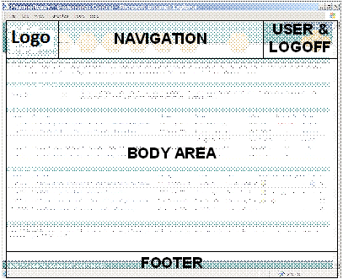

Figure 1 – Common Page Layout

|  |  |  |  |
| --- | --- | --- | --- |
| GEN-01 |  | The *Title*, *User & Logoff*, *Body* *Area*, *Navigation* and *Footer* areas are maintained throughout all the application pages. | 1.0 |
| GEN-02 |  | The *Logo* area contains pharmaREADY branding logo. | 1.0 |
| GEN-03 |  | The *User & Logoff* (user identification) area contains both the name of the currently logged-in user and a *Logoff* button for terminating the session. The *My Preferences*, *About*, *Help,* and *Search* pages are accessed through buttons in the *User & Logoff* section. | 1.0 |
| GEN-04 |  | The *Navigation* area contains a menu and sub-menu for navigating to various application pages. | 1.0 |
| GEN-05 |  | The *Body Area* contains information pertinent to the application page. This may include navigation elements specific to the application’s function. | 1.0 |
| GEN-06 |  | The *Footer* area contains a copyright statement. | 1.0 |
| GEN-07 |  | Each pharmaREADY page displays a footer that reads “XXXX Copyright © Navitas Life Sciences Ltd. All Rights Reserved” where “XXXX” is the four-digit year which frames the copyright of the release. This text is displayed under a separator horizontal line in the standard *Footer* area. | 1.0 |
| GEN-08 |  | All application pages support full functionality while running in a 1024x768 screen resolution mode. | 1.0 |
| GEN-09 |  | All date and time values are displayed using a format specified on the *My Preferences* page for the logged-in user. | 1.0 |
| GEN-10 |  | On any page that includes a list or table, the number of rows displayed in the table is limited to the number of rows specified on the *My Preferences* page for the logged-in user. | 1.0 |
| GEN-11 |  | On any page that includes a list or table where the number of rows exceeds the user’s personal preference limit, a hyperlinked paging indicator will appear at the lower right side of the table. The hyperlinked paging area will include backward, forward and hyperlinked digits representing up to five pages that are available. The currently displayed page digit will not be hyperlinked.  For example, a paged table indicator looks like the following below.    When one or more pages exist, the first page is highlighted with box  These  buttons are hyperlinked to display the table showing the first or last page respectively. These  buttons are hyperlinked to show the previous or next pages respectively.  If more than ten pages exists, then page number will be displayed like below    If fewer than five pages exist, only the number of pages that are available will be shown, as shown below. | 1.0 |
| GEN-12 |  | On any page that includes a list or table, one or more of the table headings are sort able, by clicking on the displayed heading. When first clicked, the table will sort alphabetically by the selected column and a small “sort” icon will be displayed appended to the heading label. If the same heading is clicked again, the table will sort reversed alphabetically by the selected column and a small “reverse sort” icon will be appended to the heading label. | 1.0 |
| GEN-13 |  | By sorting tables, clicking on heading labels will sort all the rows on the other pages should the tables extend to other pages, not just the rows currently displayed on the page to the user. | 1.0 |
| GEN-14 |  | The  button is used to redirect to respective central page | 1.0 |
| GEN-15 |  | The  button is used to export the grid results in the excel format | 1.0 |
| GEN-16 |  | The  used to create the new entry for the respective model | 1.0 |
| GEN-17 |  | The icon is used to view the respective grid entry | 1.0 |

## User and Access Rights Management

### Roles and View Access Rights

The pharmaREADY IDMP application supports specific roles, each with specific data access rights that are applied by the administrator. Each role is predefined in the system but can be edited.

|  |  |  |
| --- | --- | --- |
| ROL-01 IDMP Admin | 1. Marketing 2. Medicinal 3. Pharmaceutical 4. Packaging 5. Manufacturing 6. Clinical 7. Substance 8. IDMP Author 9. IDMP Reviewer 10. IDMP Approver 11. View Audit Log | 1.0 |
| ROL-02 Marketing Viewer | 1. **Marketing** 2. Medicinal 3. Pharmaceutical 4. Packaging 5. Manufacturing 6. Clinical 7. Substance 8. IDMP Author 9. IDMP Reviewer 10. IDMP Approver 11. View Audit Log | 1.0 |
| ROL-03 Medicinal Product Viewer | 1. Marketing 2. **Medicinal** 3. Pharmaceutical 4. Packaging 5. Manufacturing 6. Clinical 7. Substance 8. IDMP Author 9. IDMP Reviewer 10. IDMP Approver 11. View Audit Log | 1.0 |
| ROL-04 Pharmaceutical Viewer | 1. Marketing 2. Medicinal 3. **Pharmaceutical** 4. Packaging 5. Manufacturing 6. Clinical 7. Substance 8. IDMP Author 9. IDMP Reviewer 10. IDMP Approver 11. View Audit Log | 1.0 |
| ROL-05 Package Viewer | 1. Marketing 2. Medicinal 3. Pharmaceutical 4. **Packaging** 5. Manufacturing 6. Clinical 7. Substance 8. IDMP Author 9. IDMP Reviewer 10. IDMP Approver 11. View Audit Log | 1.0 |
| ROL-06 Manufacture Viewer | 1. Marketing 2. Medicinal 3. Pharmaceutical 4. Packaging 5. **Manufacturing** 6. Clinical 7. Substance 8. IDMP Author 9. IDMP Reviewer 10. IDMP Approver 11. View Audit Log | 1.0 |
| ROL-07 Clinical Viewer | 1. Marketing 2. Medicinal 3. Pharmaceutical 4. Packaging 5. Manufacturing 6. **Clinical** 7. Substance 8. IDMP Author 9. IDMP Reviewer 10. IDMP Approver 11. View Audit Log | 1.0 |
| ROL-08 Substance Viewer | 1. Marketing 2. Medicinal 3. Pharmaceutical 4. Packaging 5. Manufacturing 6. Clinical 7. **Substance** 8. IDMP Author 9. IDMP Reviewer 10. IDMP Approver 11. View Audit Log | 1.0 |
| ROL-09 Author | 1. Marketing 2. Medicinal 3. Pharmaceutical 4. Packaging 5. Manufacturing 6. Clinical 7. Substance 8. **IDMP Author** 9. IDMP Reviewer 10. IDMP Approver 11. **View Audit Log** | 1.0 |
| ROL-10 Reviewer | 1. Marketing 2. Medicinal 3. Pharmaceutical 4. Packaging 5. Manufacturing 6. Clinical 7. Substance 8. IDMP Author 9. **IDMP Reviewer** 10. IDMP Approver 11. **View Audit Log** | 1.0 |
| ROL-11 Medicinal Product Viewer | 1. Marketing 2. Medicinal 3. Pharmaceutical 4. Packaging 5. Manufacturing 6. Clinical 7. Substance 8. IDMP Author 9. IDMP Reviewer 10. **IDMP Approver** 11. **View Audit Log** | 1.0 |

## Reports

## Application Page Specifications

### Upload

The IDMP process tightly coupled with TrackWise application. The upload page will load from TW application. Both PR and TW applications are using AD then user will automatically authenticate based on the AD integration

In this integration, the upload process can be initiated upon any process from TrackWise application. The process and state name are configurable in IDMP application.

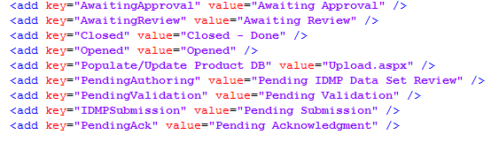

The *Upload* page is used to upload data from different sources. The different sources are described in the section 4.1.1. All the uploaded data are process and save. Once it is saved then ready for review process.

The *Upload* page is similar to the following below.

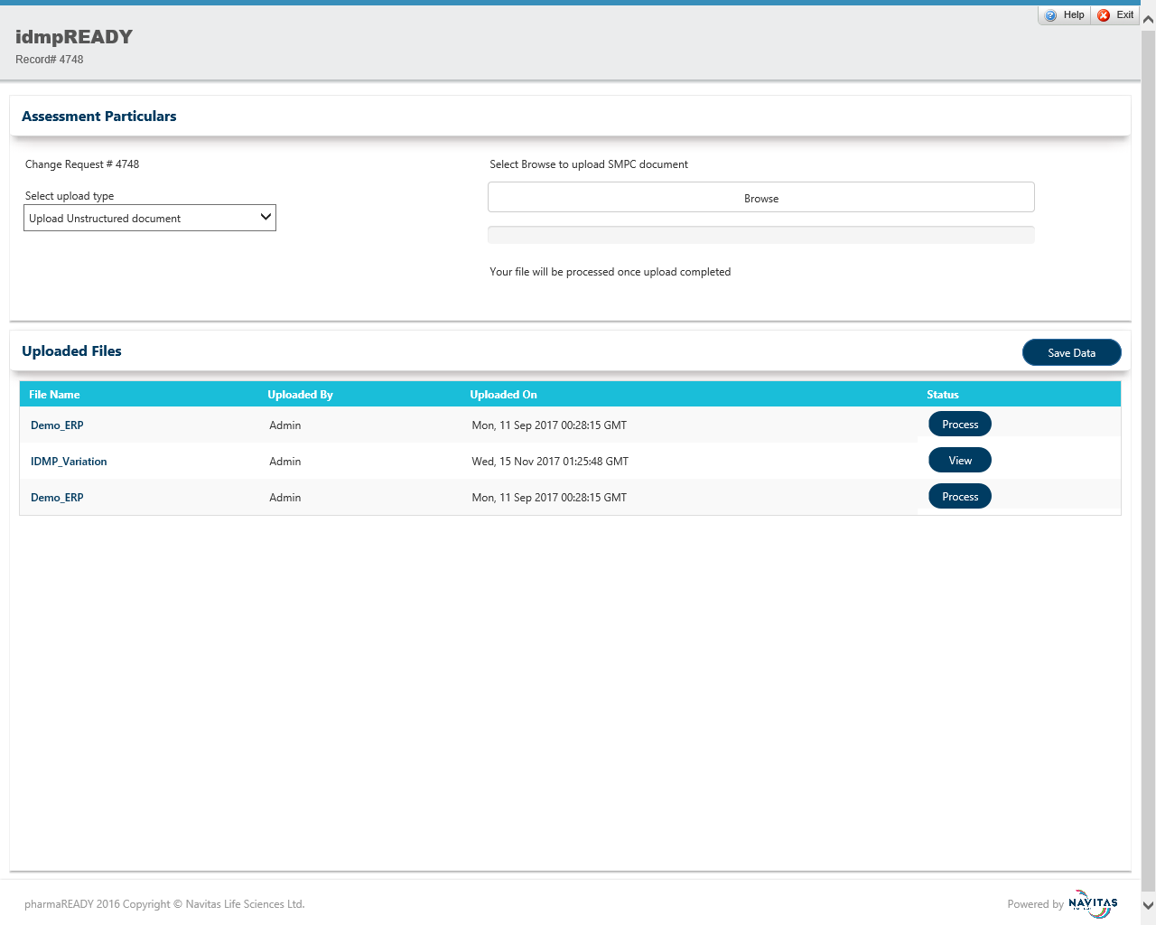

Figure: **4.3.1.1 - Upload Page**

|  |  |  |
| --- | --- | --- |
| UPP-01 |  | The *Upload* page displays the following fields below. |

|  | Label | Type | Options | Required Field? | Access Rules | Default Value | Max Length | Validation? |  |
| --- | --- | --- | --- | --- | --- | --- | --- | --- | --- |
| A | Select upload type | Dropdown | List of Sources from section 4.1.1 | No |  | <Upload Unstructured Document> |  | No | 1.0 |
| b | Select Excel templates | Dropdown | List of active accessible excel templates | No |  | <Latest template list first> |  | No | 1.0 |
| c | Select Database | Dropdown | List of active accessible Databases | No |  | <Latest Database list first> |  | No | 1.0 |
| d | Browse | File | Available for all the sources which could be in file format | No |  |  |  | No | 1.0 |
| e |  | Button |  | No |  |  |  | Database has to be selected | 1.0 |
| f |  | Button |  | No |  |  |  | Any source data has to uploaded or added | 1.0 |
| g |  | Button |  | No |  |  |  |  | 1.0 |
| h |  | Button |  | No |  |  |  |  | 1.0 |

|  |  |  |
| --- | --- | --- |
| UPP-02 |  | The *Upload* page has the following field validation below. |

|  | Item | Action | Condition | Outcome Rules |  |
| --- | --- | --- | --- | --- | --- |
| a | Browse | Select / Choose File | The upload type list box is set to *Unstructured Document and select other than PDF files* | Invalid File format | 1.0 |
| b | Browse | Select / Choose File | The upload type list box is set to *Unstructured Document and select other than PDF files* | Invalid File format | 1.0 |
| c | Browse | Select / Choose File | The upload type list box is set to *Unstructured Document and select other than PDF files* | Invalid File format | 1.0 |

|  |  |  |
| --- | --- | --- |
| UPP-03 |  | The Uploadpage has the following active elements below. |

|  | Element | Type | Navigate | Action | Access Rules | Hover Behavior |  |
| --- | --- | --- | --- | --- | --- | --- | --- |
| a | Select upload type | Dropdown | No | Selects the upload type of the source |  |  | 1.0 |
| b | Select Excel templates | Dropdown | No | Selects the Excel Template if the upload type of the Source is Excel Template |  |  | 1.0 |
| c | Select Database | Dropdown | No | Selects the Database if the upload type of the Source is Database |  |  | 1.0 |
| d | Browse | File | No | Selects the selected file for processing |  |  | 1.0 |
| e |  | Button | No | Add the Database selected for processing |  |  | 1.0 |
| f |  | Button | No | Save all the selected data sources based on the Golden Source and prioritization |  |  | 1.0 |
| g |  | Button | No | Processed the particular data source of the row selected |  |  | 1.0 |
| h |  | Button | No | Displays the details of the data field mapped for the category. |  |  | 1.0 |

### Review Source

Once author collected values from different sources and initiate the review process.

Reviewer logged in from TrackWise application and click on the launch link then IMDP review screen will popped up

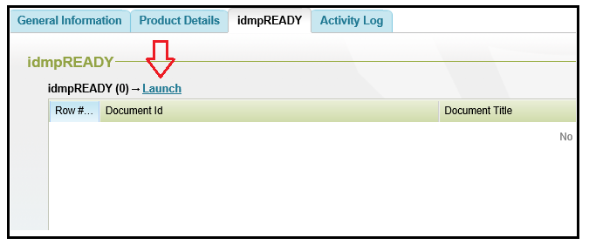

Figure 4.3.2.1 **TrackWise IDMP Process initiation**

The *Reviewer* page is similar to the following below

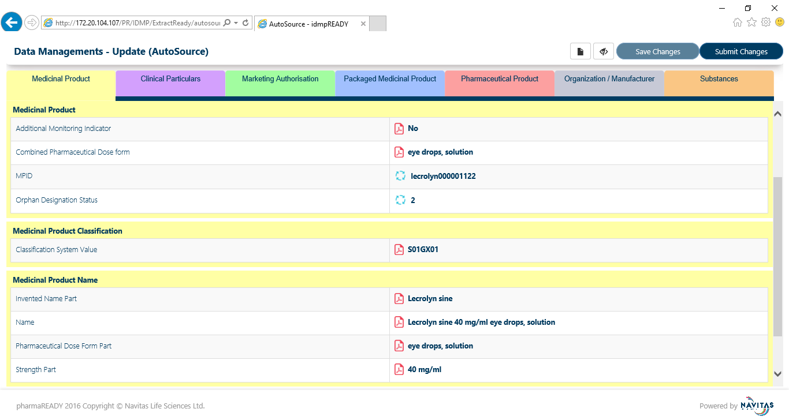

Figure 4.3.2.2 **Medicinal Product Category**

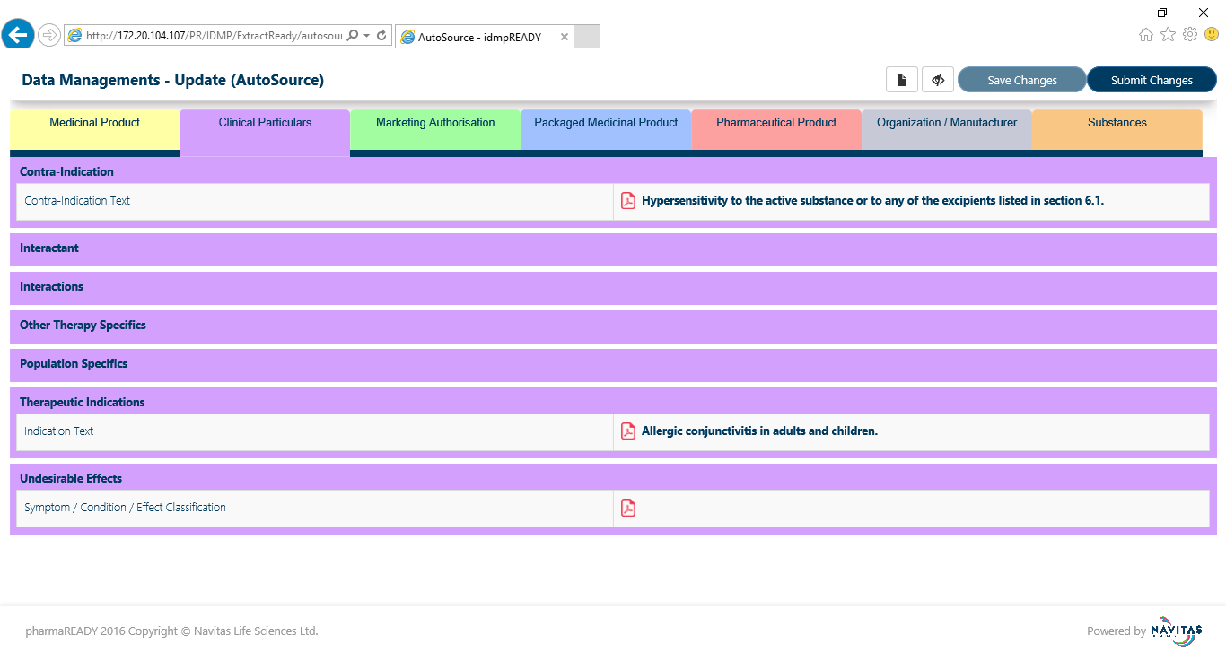

Figure 4.3.2.3 **Clinical Particulars**

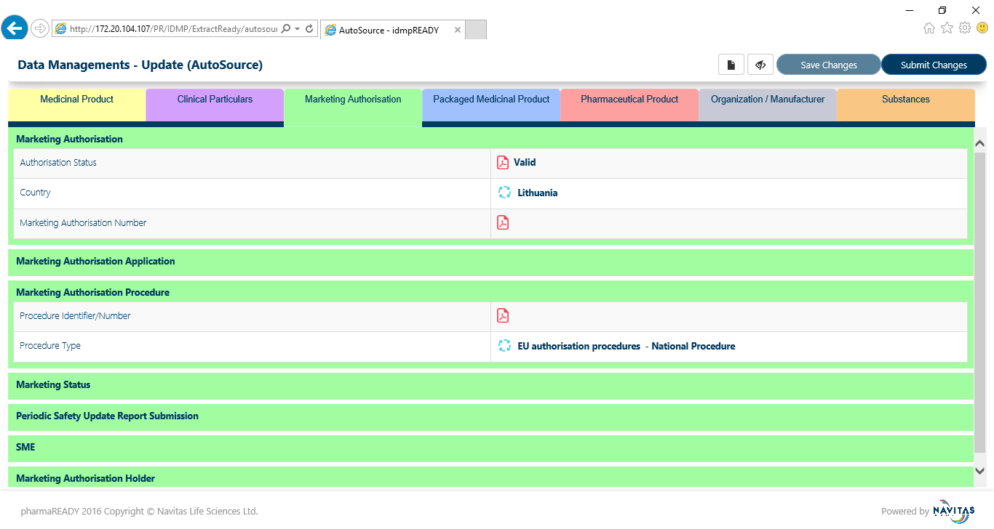

Figure 4.3.2.4 **Marketing Authorization**

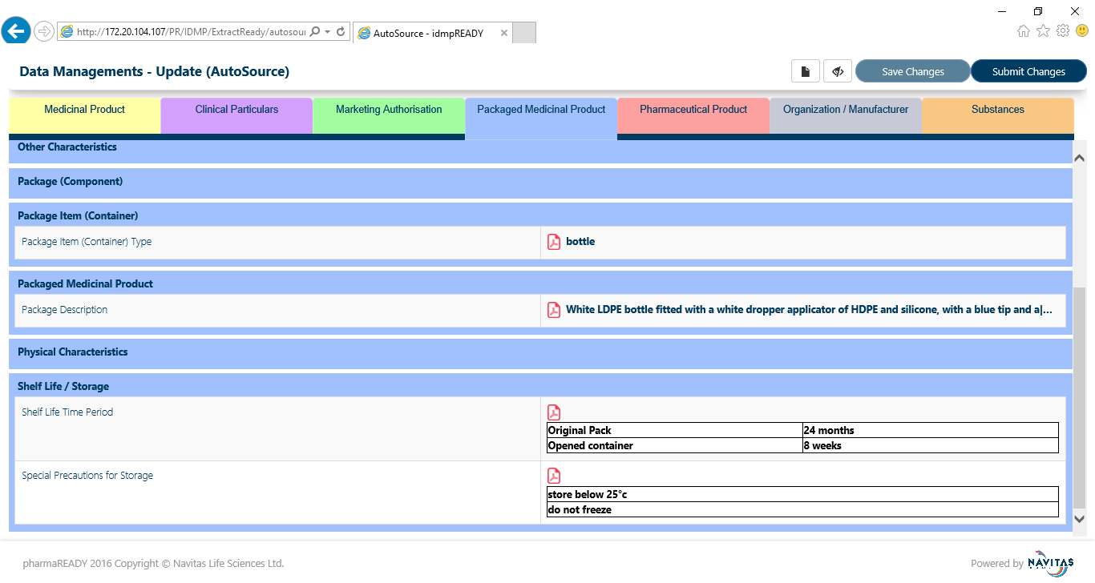

Figure 4.3.2.5 **Packaged Medicinal Product**

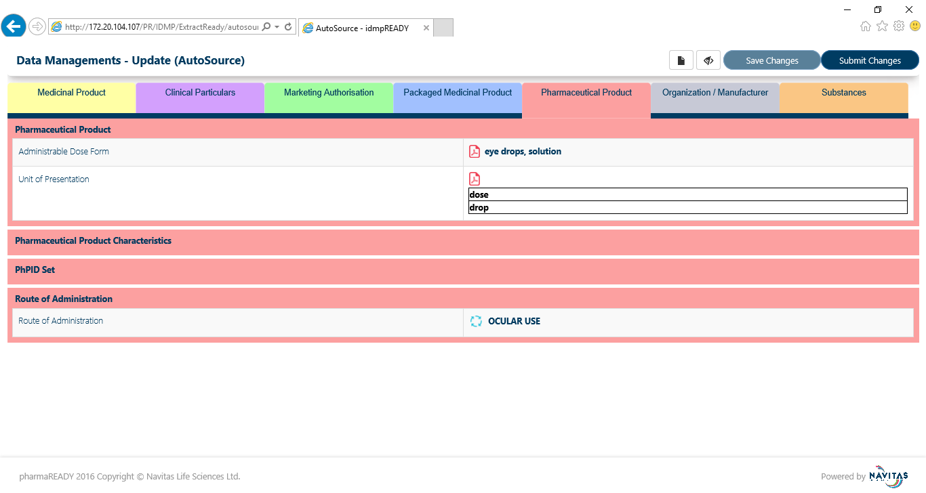

Figure 4.3.2.6 **Pharmaceutical Product**

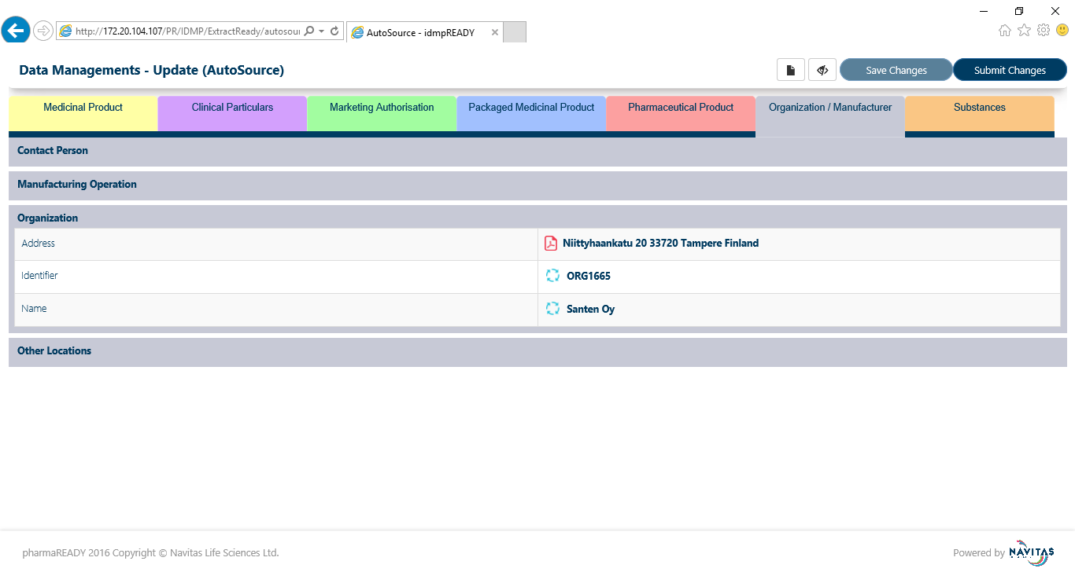

Figure 4.3.2.7 **Manufacturer**

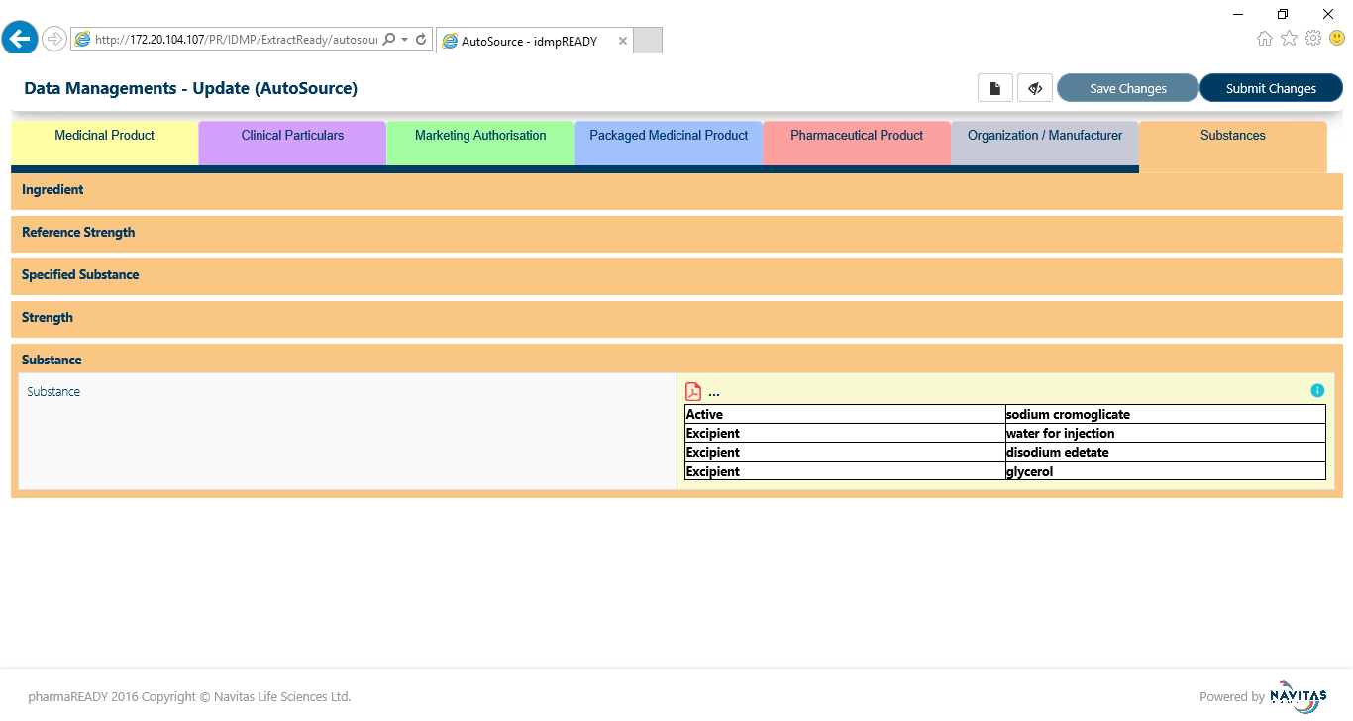

Figure 4.3.2.8 **Substances**

Click on the any attribute value then pop up will open. Reviewer change and save the value

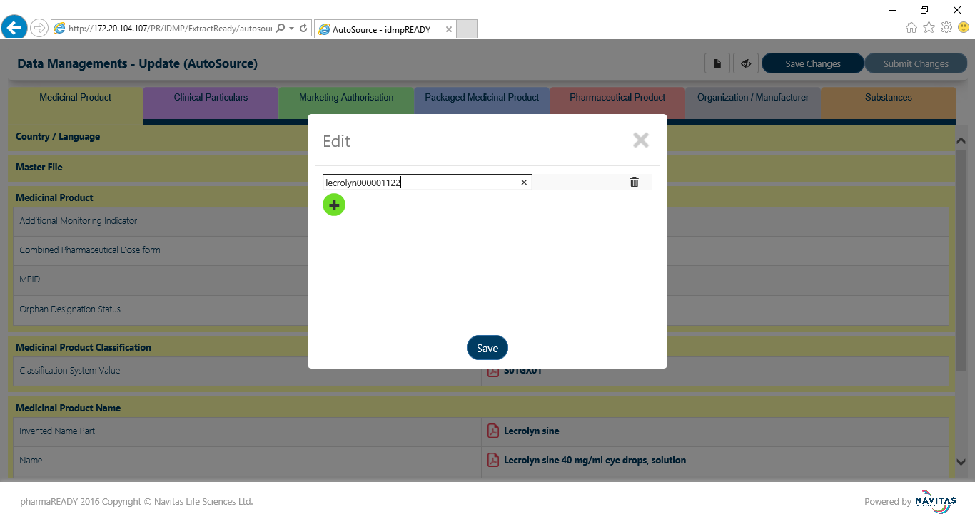

Figure 4.3.2.9 **Edit Attribute Value**

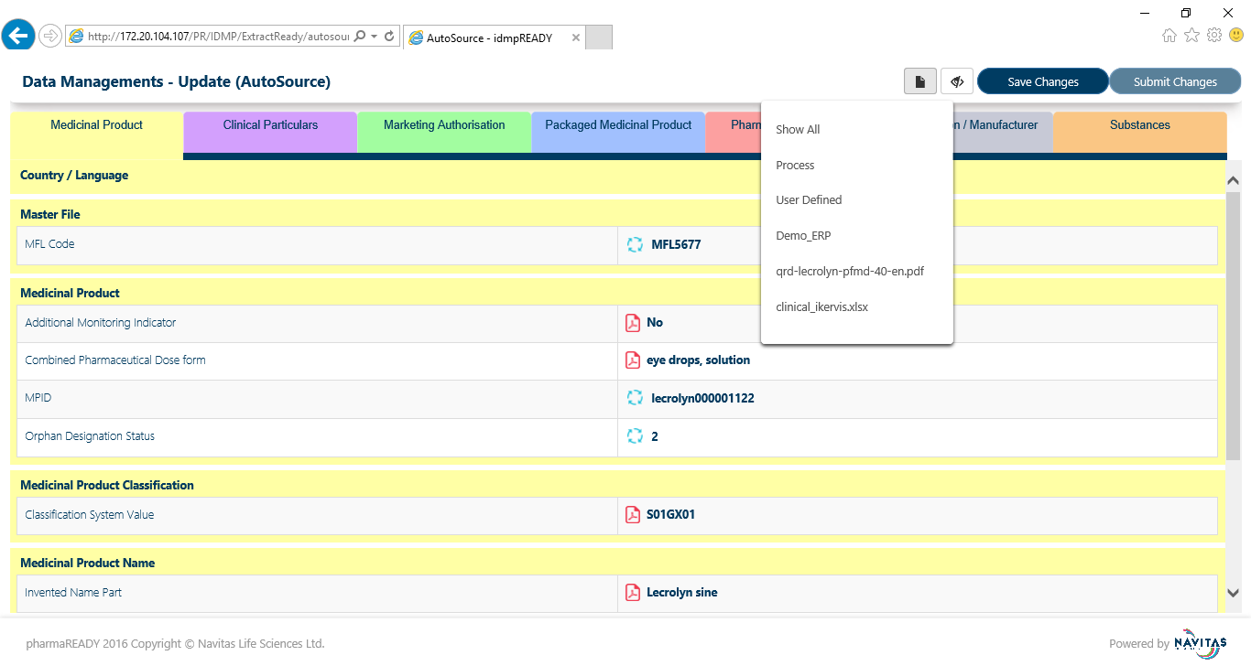

Figure 4.3.2.10 Filter **option to view selected source**

**REV -001** The *Review* page displays the following fields below

| Label | Type | Options | Required Field? | Access Rules | Default Value | Max Length | Validation? |  |
| --- | --- | --- | --- | --- | --- | --- | --- | --- |
| Medicinal Product | Tab |  | No | Load attribute values based on the priority |  |  | No | 1.0 |
| Clinical Particulars | Tab |  | No | Load attribute values based on the priority |  |  | No | 1.0 |
| Marketing Authorization | Tab |  | No | Load attribute values based on the priority |  |  | No | 1.0 |
| Packaged Medicinal Product | Tab |  | No | Load attribute values based on the priority |  |  | No | 1.0 |
| Pharmaceutical Product | Tab |  | No | Load attribute values based on the priority |  |  | No | 1.0 |
| Manufacturer | Tab |  | No | Load attribute values based on the priority |  |  | No | 1.0 |
| Substances | Tab |  | No | Load attribute values based on the priority |  |  | No | 1.0 |
| Filter | Icon |  | No | Filter based on the selected source |  |  | No | 1.0 |
| Hide/Show | Icon |  | No | Click on the icon it will visible all attributes or hide null value attribute |  |  |  |  |
| Edit | Textbox |  | No | Populate textbox along with value. User can able to edit and save |  |  | No | 1.0 |
|  | Button |  | No |  |  |  | No | 1.0 |
|  | Button |  | No |  |  |  | Enable, If any attribute value got changed | 1.0 |
|  | Button |  | No |  |  |  | Enable, If all changes are saved | 1.0 |

### Approve Process

Once reviewer submit the record it will move to approve process. Approver logged in from TrackWise application and click on the launch link then IMDP approve screen will be popped up



Figure 4.3.3.1 **TrackWise IDMP Process initiation**

The *Approval* page is similar to the following below

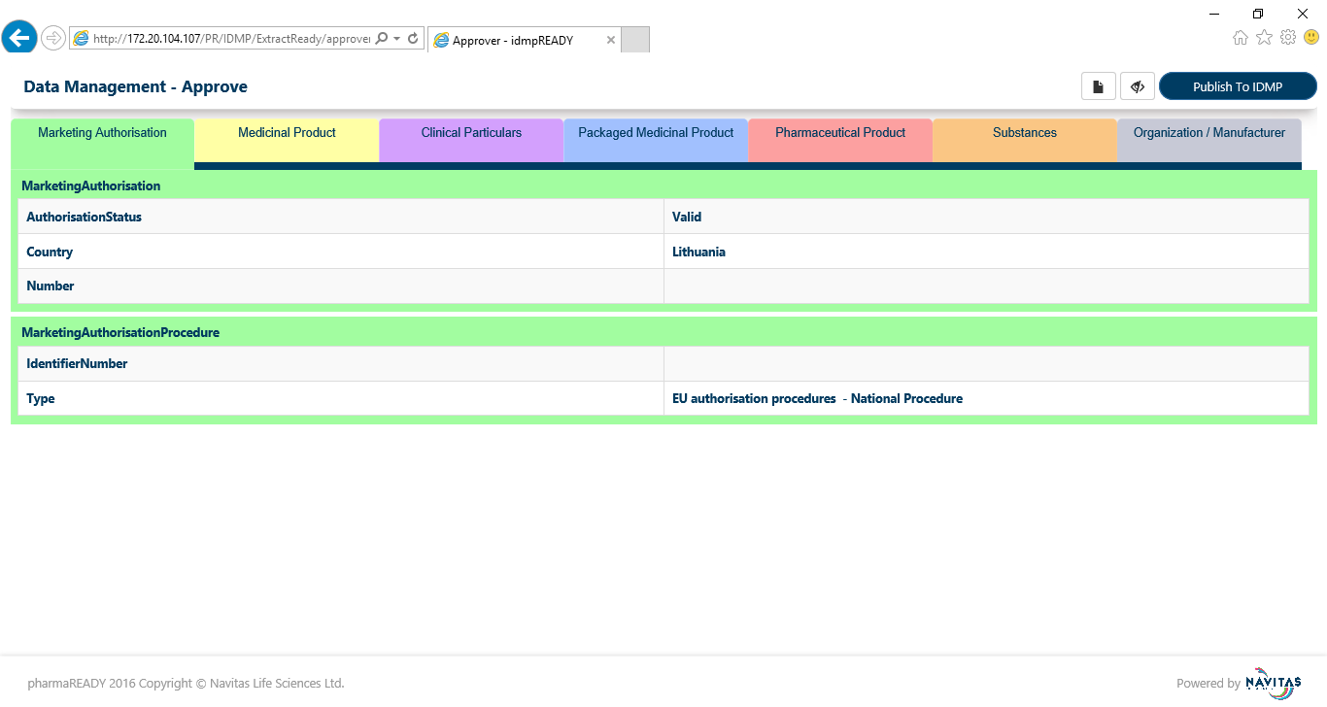

Figure 4.3.3.2 **Marketing Authorization**

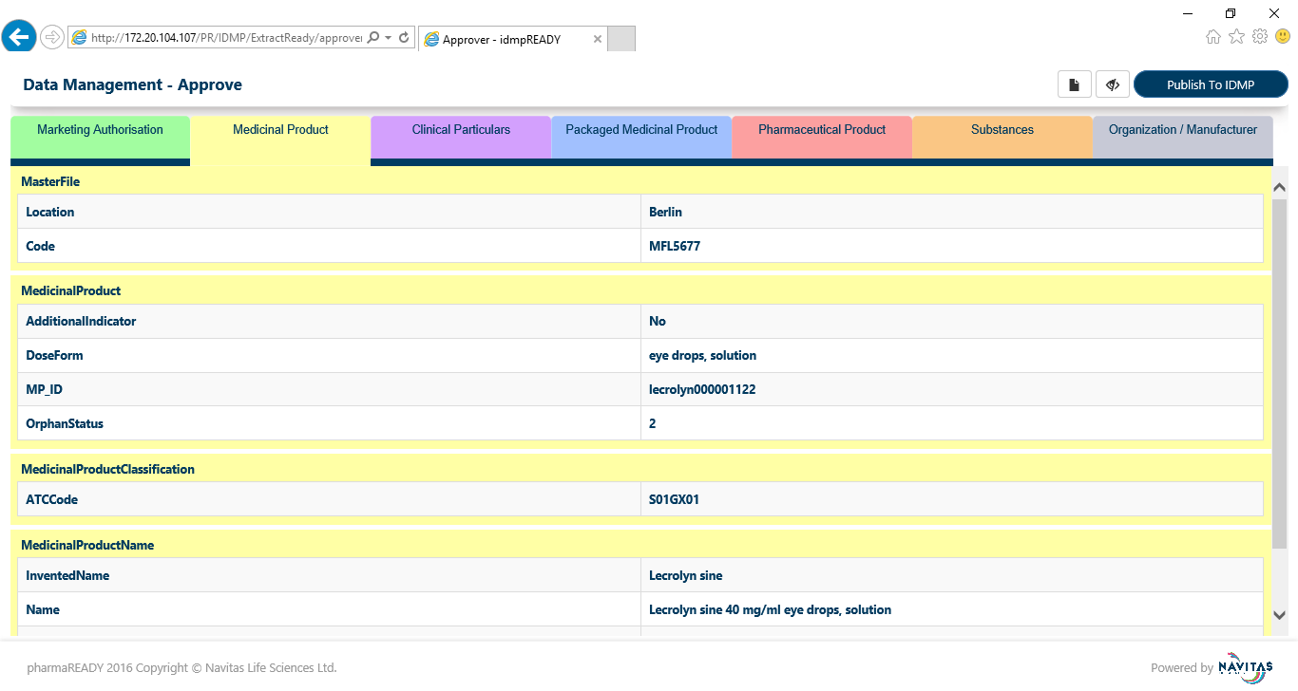

Figure 4.3.3.3 **Medicinal Product Category**

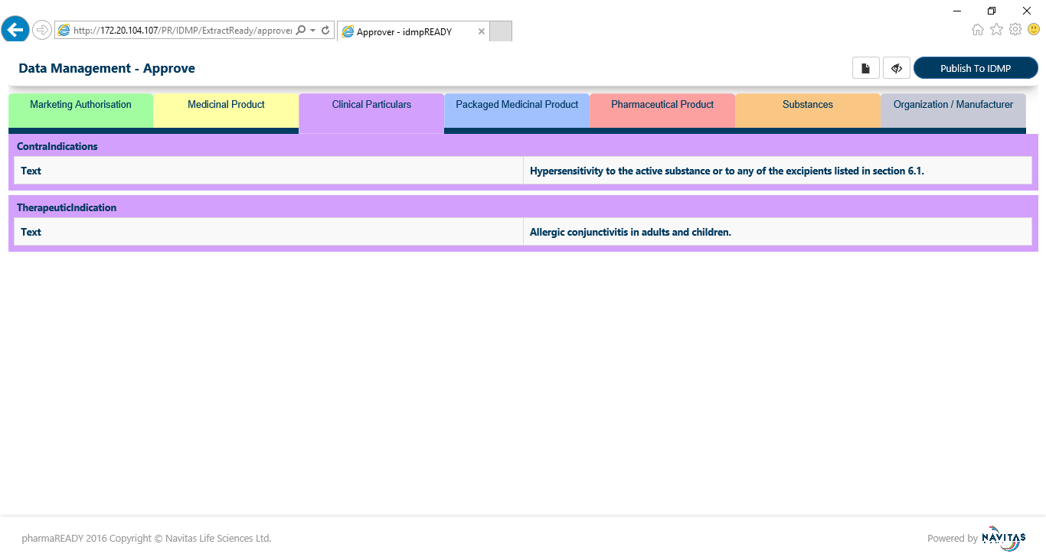

Figure 4.3.3.4 **Clinical Particulars**

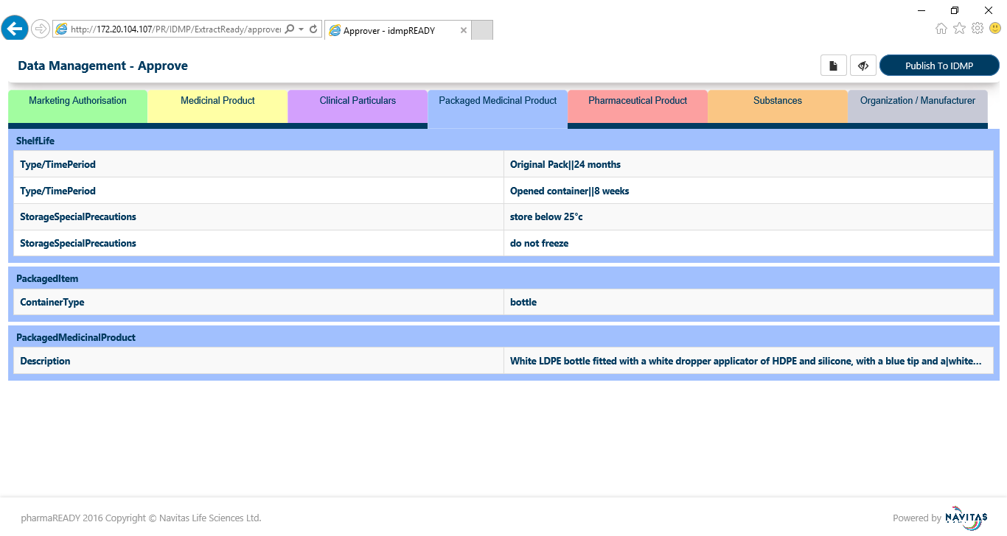

Figure 4.3.3.5 **Packaged Medicinal Product**

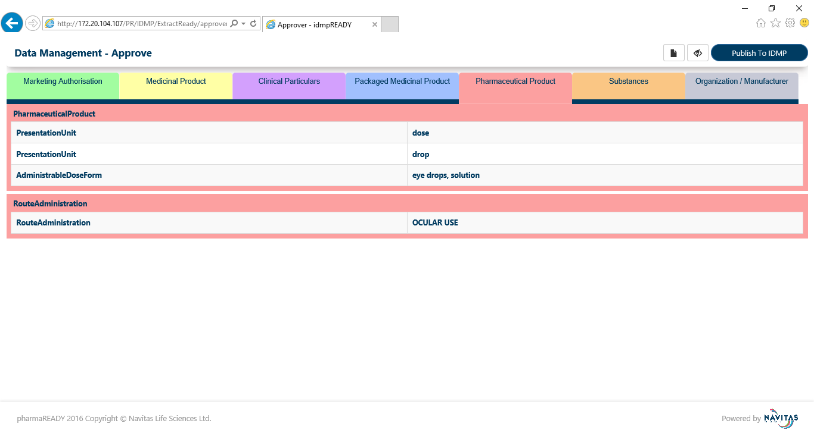

Figure 4.3.3.6 **Pharmaceutical Product**

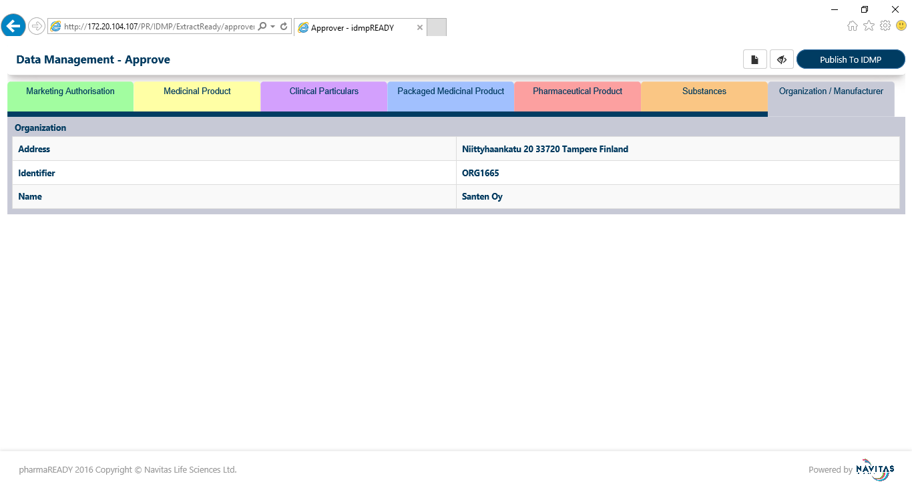

Figure 4.3.3.7 **Manufacture**

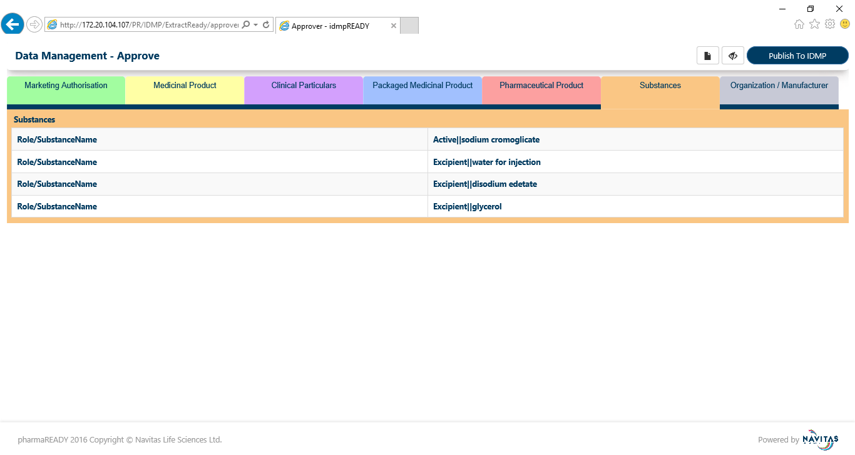

Figure 4.3.3.8 **Substances**

**APP -001** The *Approve* page displays the following fields below

| Label | Type | Options | Required Field? | Access Rules | Default Value | Max Length | Validation? |  |
| --- | --- | --- | --- | --- | --- | --- | --- | --- |
| Medicinal Product | Tab |  | No | Load attribute values based on the priority |  |  | No | 1.0 |
| Clinical Particulars | Tab |  | No | Load attribute values based on the priority |  |  | No | 1.0 |
| Marketing Authorization | Tab |  | No | Load attribute values based on the priority |  |  | No | 1.0 |
| Packaged Medicinal Product | Tab |  | No | Load attribute values based on the priority |  |  | No | 1.0 |
| Pharmaceutical Product | Tab |  | No | Load attribute values based on the priority |  |  | No | 1.0 |
| Manufacturer | Tab |  | No | Load attribute values based on the priority |  |  | No | 1.0 |
| Substances | Tab |  | No | Load attribute values based on the priority |  |  | No | 1.0 |
| Filter | Icon |  | No | Filter based on the selected source |  |  | No | 1.0 |
| Hide/Show | Icon |  | No | Click on the icon it will visible all attributes or hide null value attribute |  |  |  | 1.0 |
|  | Button |  | No | All values push to IDMP model |  |  |  | 1.0 |

### Category wise View

* + - 1. **Medicinal**

All attributes are in the read-only mode in view screen. The screens are look like below

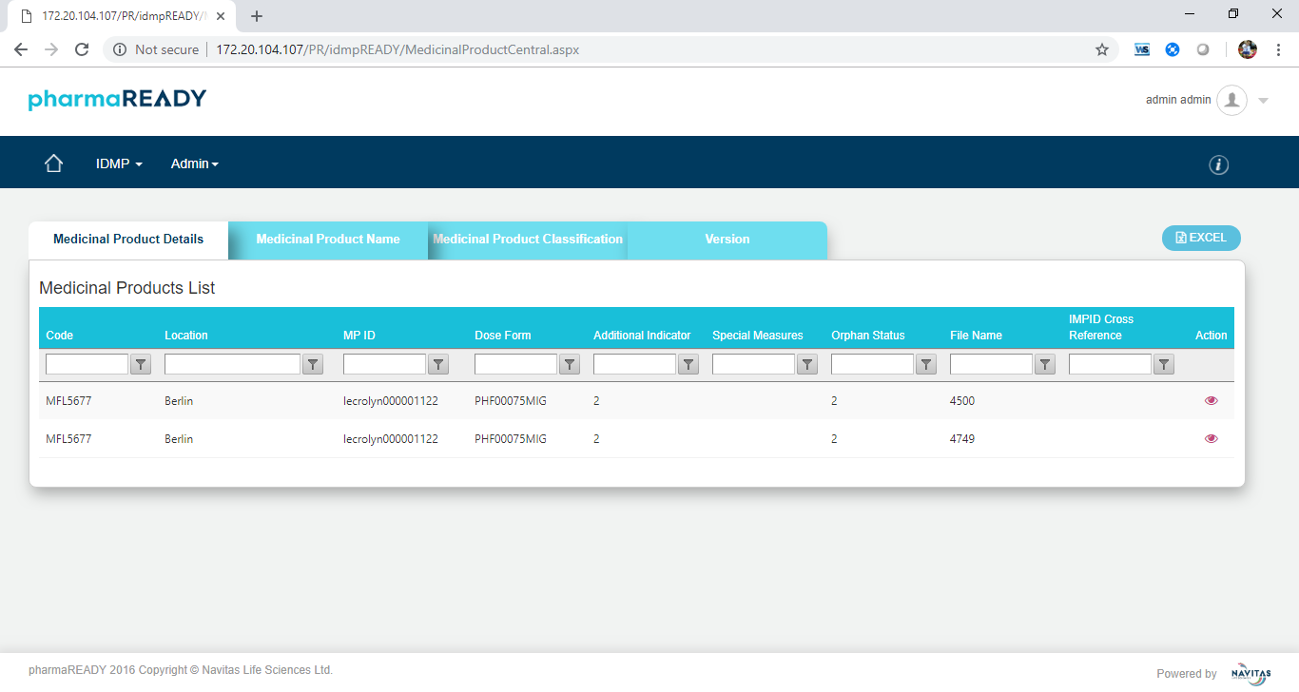

Figure 4.3.4.1.1 **Medicinal Product Details Grid View**

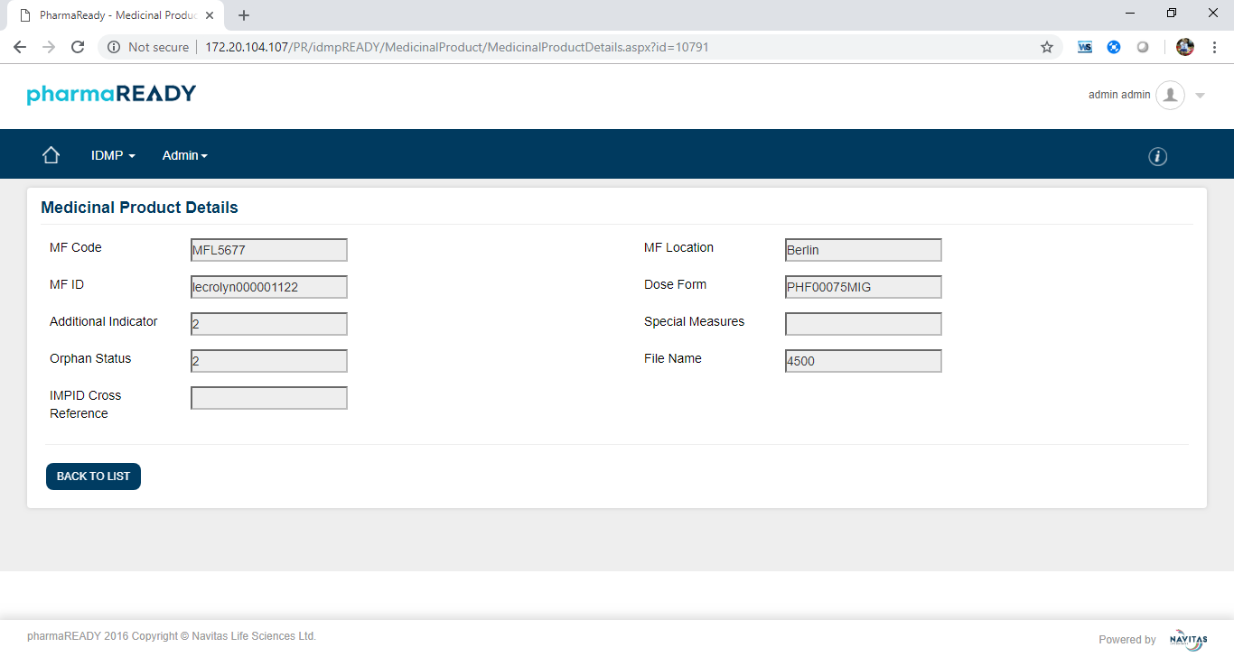

Figure 4.3.4.1.2 **Medicinal Product Details**

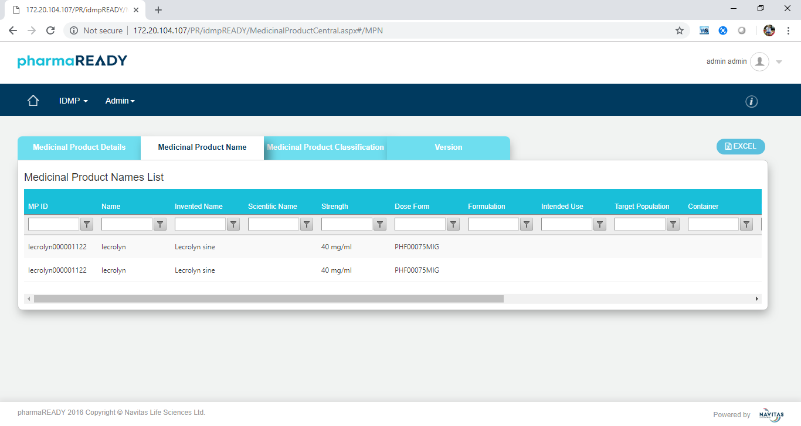

Figure 4.3.4.1.3 **Medicinal Product Name Grid View**

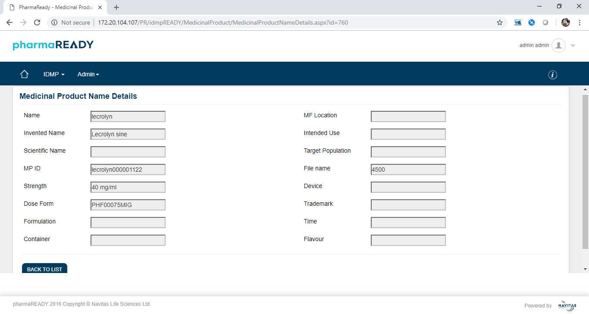

Figure 4.3.4.1.4 **Medicinal Product Name Details**

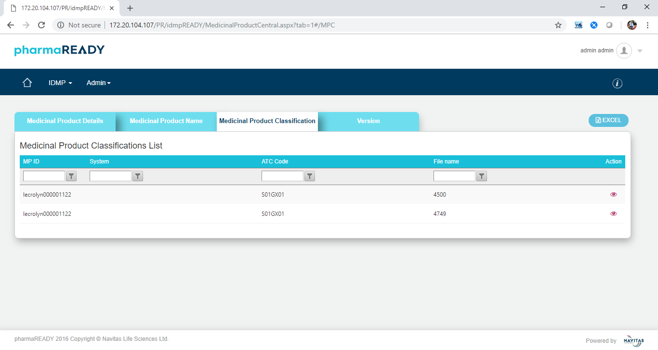

Figure 4.3.4.1.5 **Medicinal Product Classification**

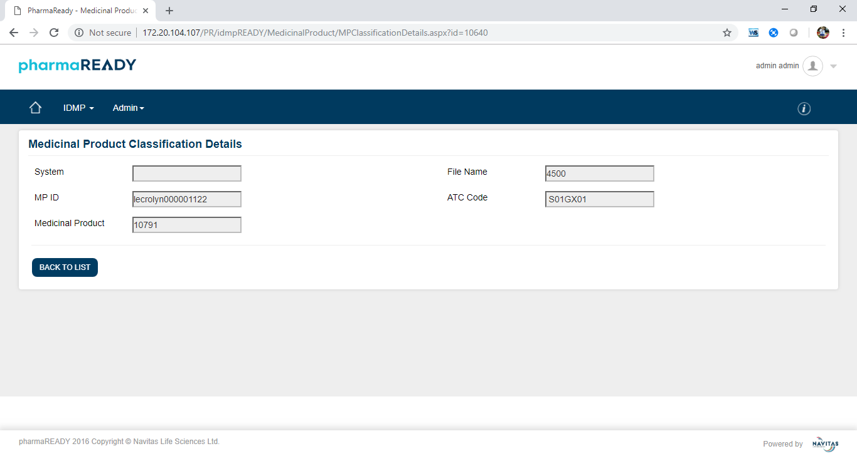

Figure 4.3.4.1.6 **Medicinal Product Classification Details**

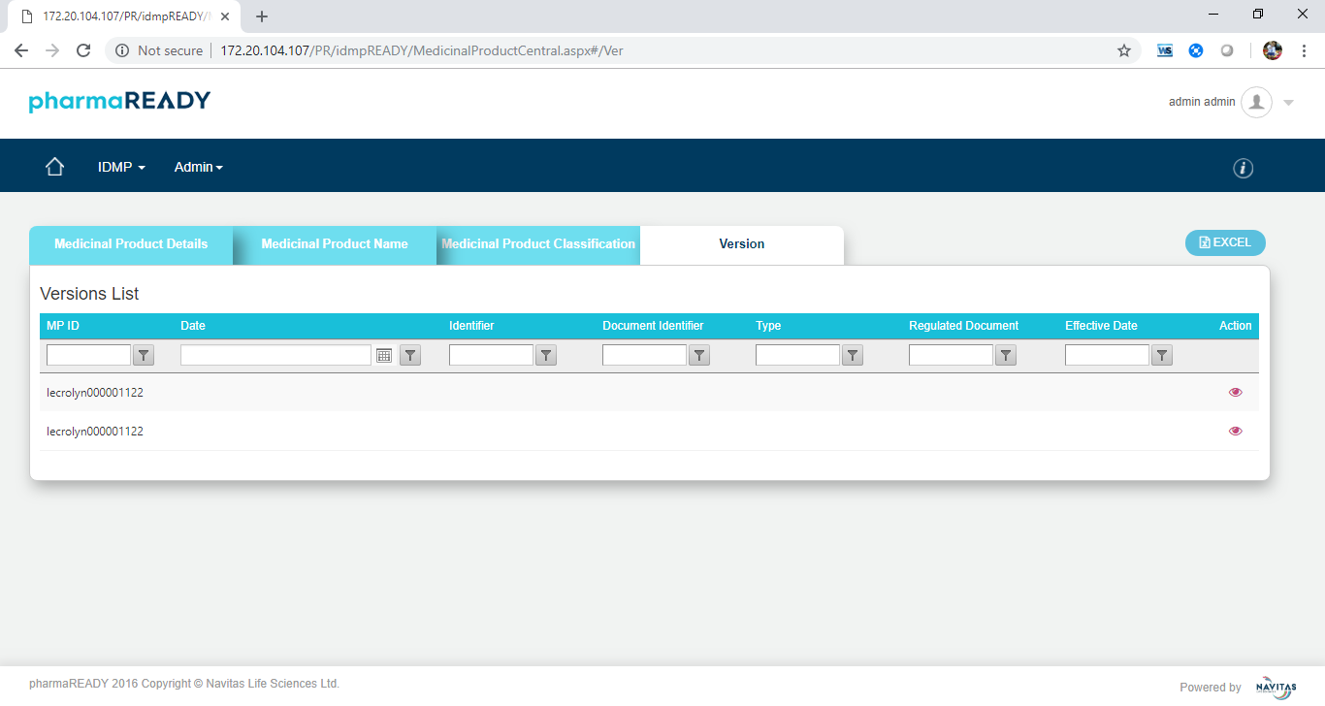

Figure 4.3.4.1.7 **Version Grid View**

* + - 1. **Clinical Particulars**

All attributes are in the read-only mode in view screen. The screens are look like below

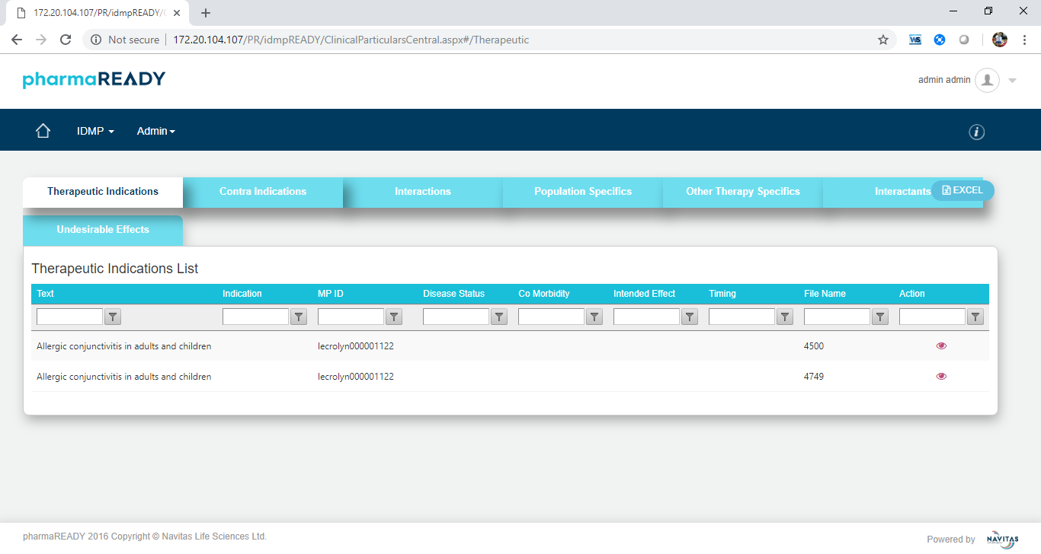

Figure 4.3.4.2.1 **Therapeutic Indications Grid View**

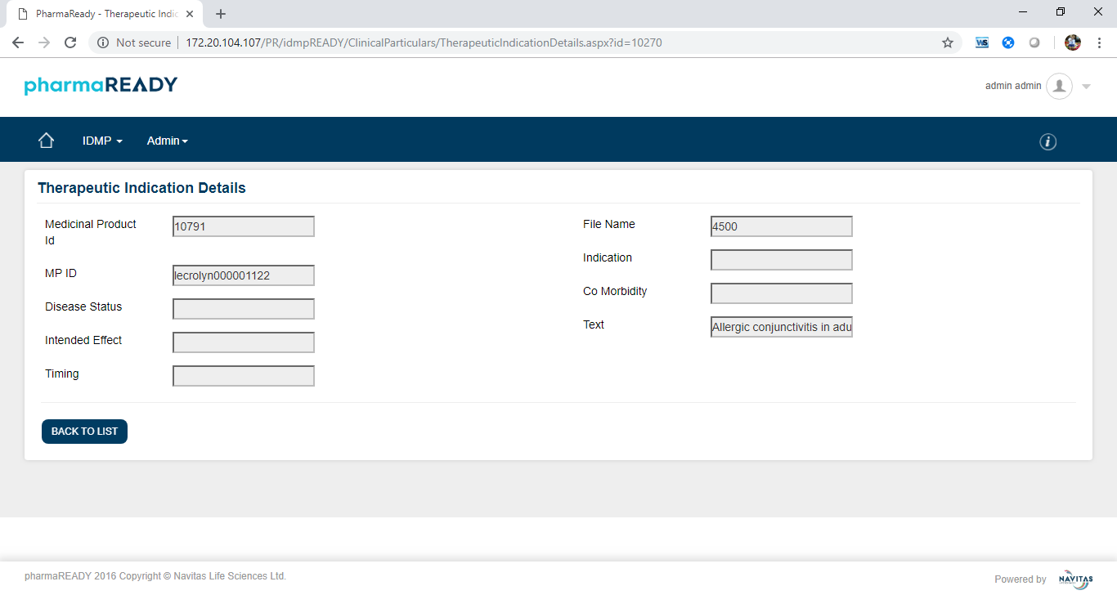

Figure 4.3.4.2.2 **Therapeutic Indications Details View**

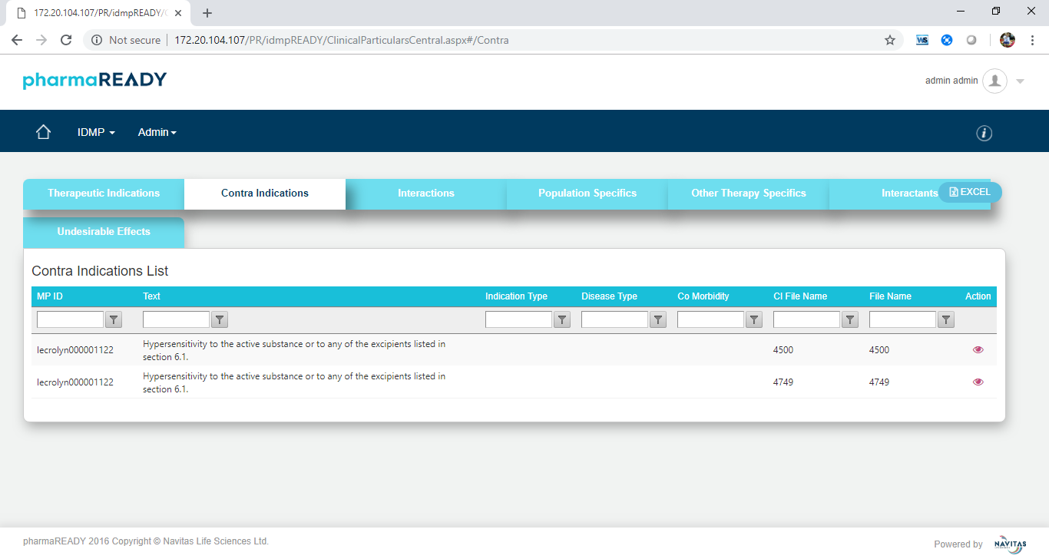

Figure 4.3.4.2.3 **Contra Indications Grid View**

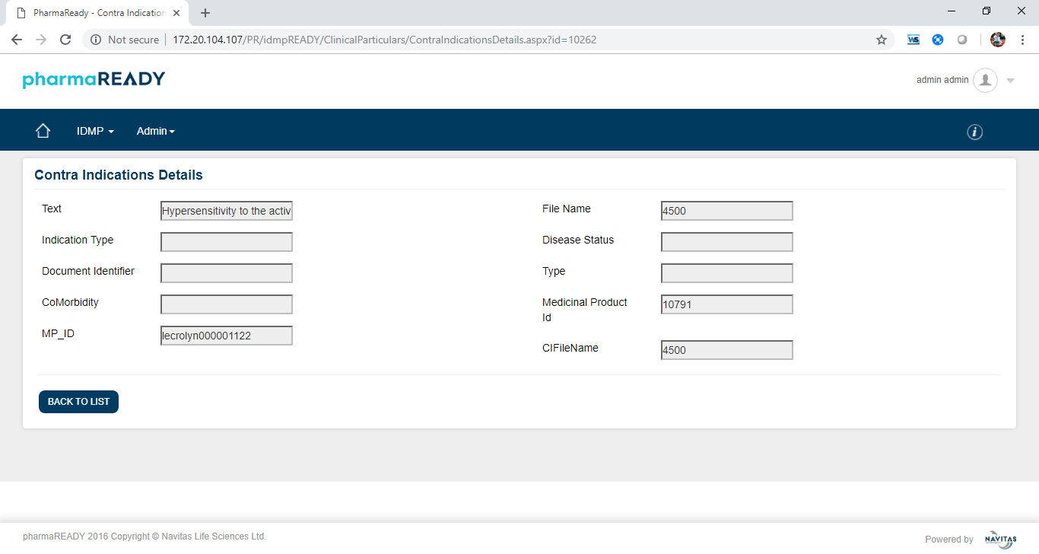

Figure 4.3.4.2.4 **Contra Indications Details View**

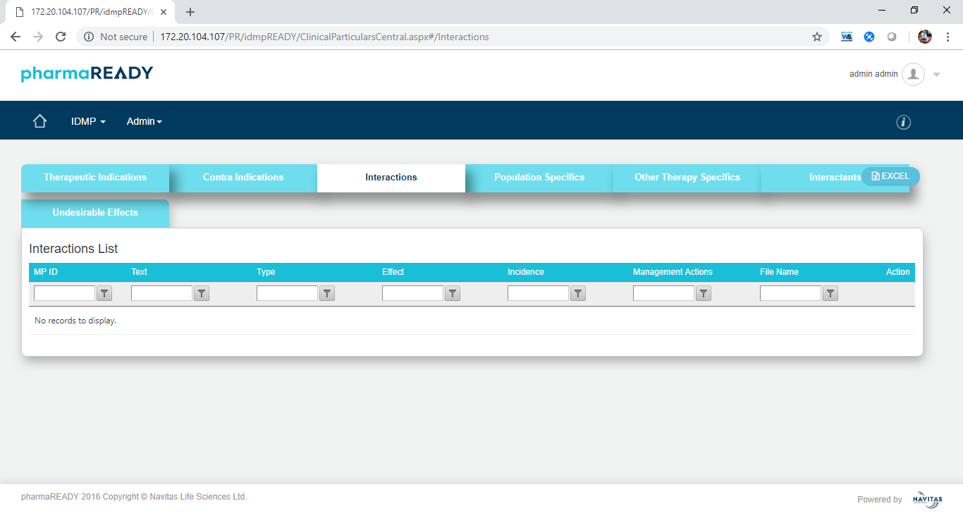

Figure 4.3.4.2.5 **Interactions Grid View**

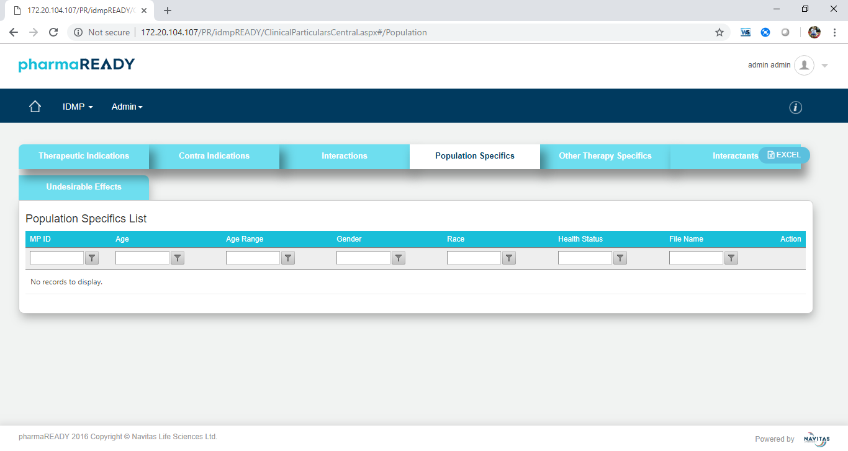

Figure 4.3.4.2.6 **Population Specifics Grid View**

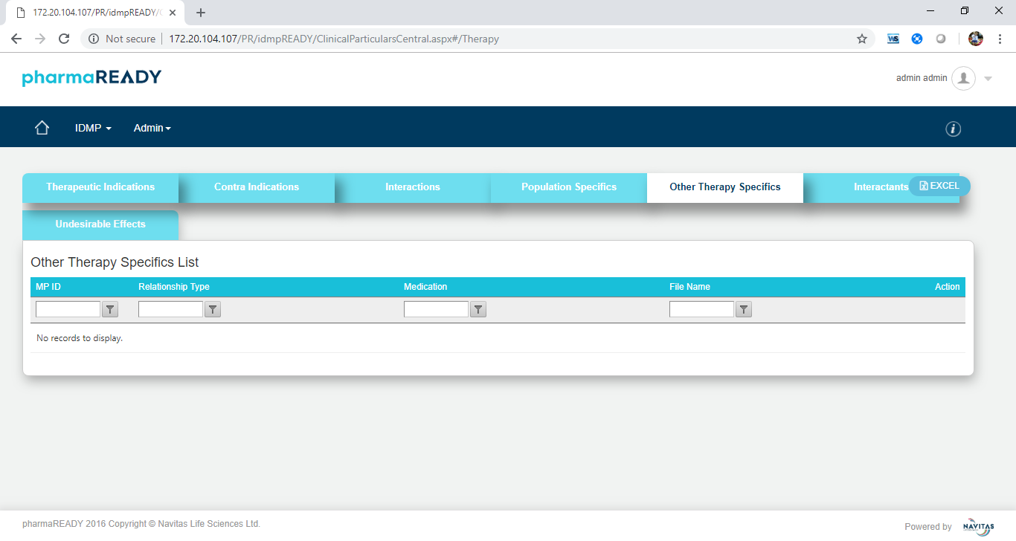

Figure 4.3.4.2.7 **Other Therapy Specifics Grid View**

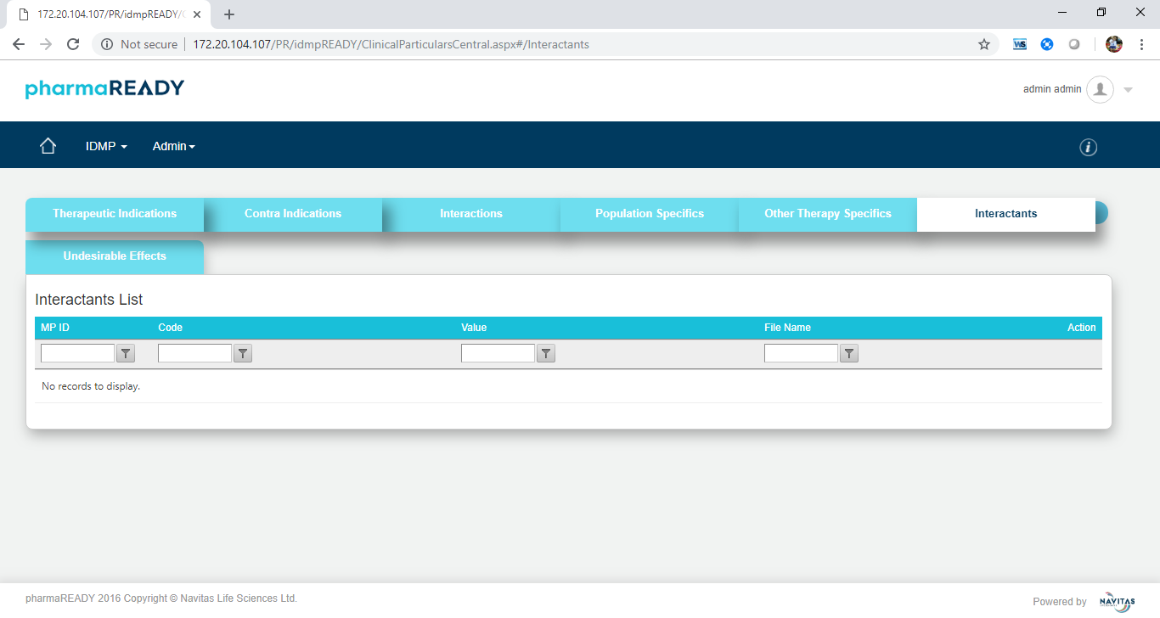

Figure 4.3.4.2.8 **Interactants Grid View**

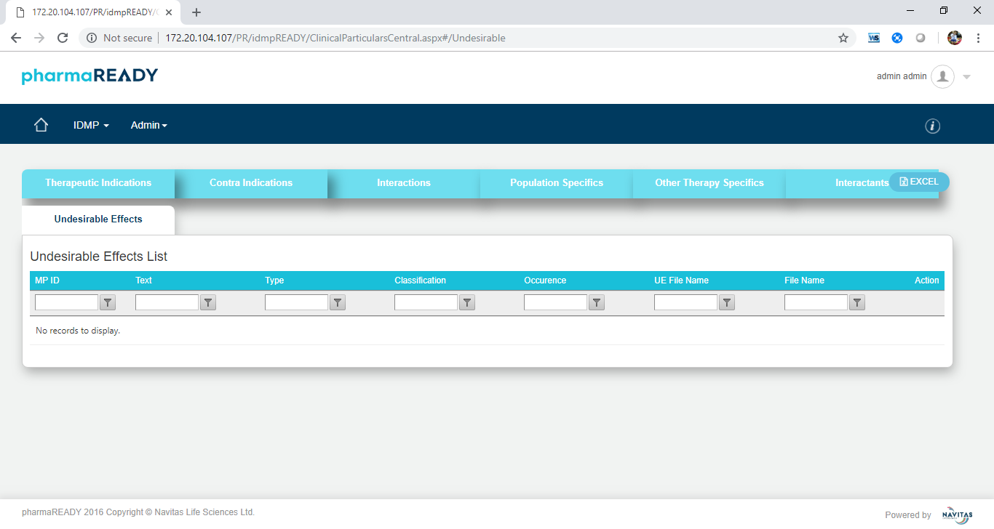

Figure 4.3.4.2.9 **Undesirable Effects** **Grid View**

* + - 1. **Marketing Authorisation**

All attributes are in the read-only mode in view screen. The screens are look like below

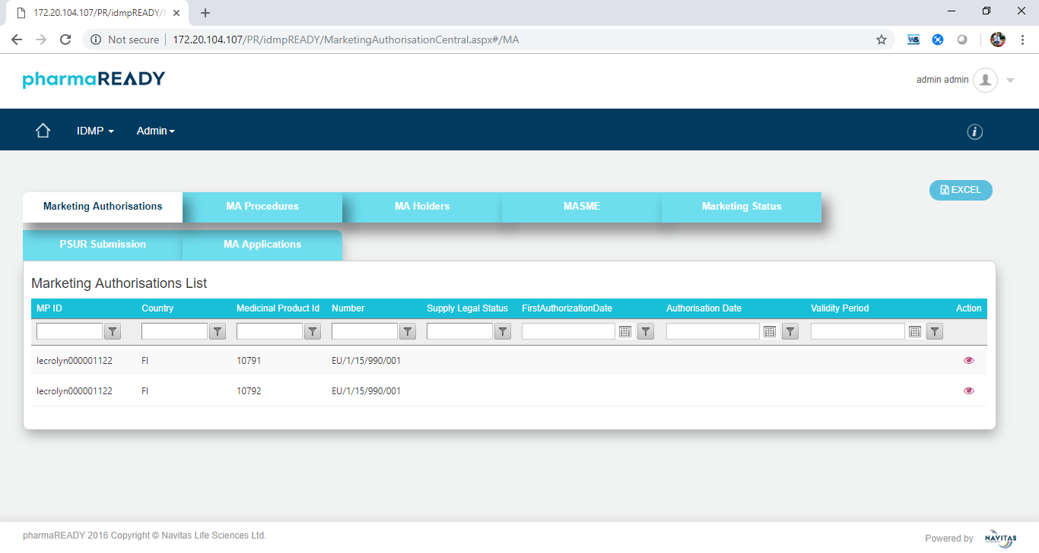

Figure 4.3.4.3.1 **Marketing Authorisations Grid View**

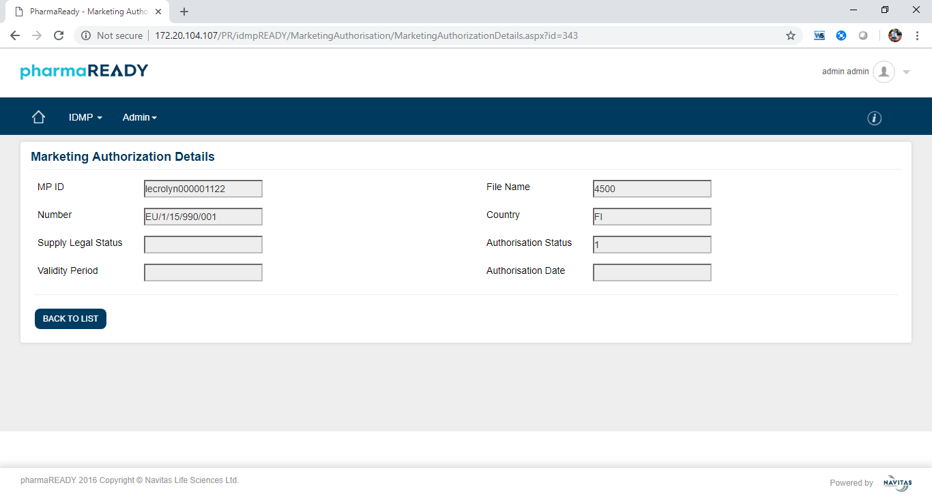

Figure 4.3.4.3.2 **Marketing Authorisations Details View**

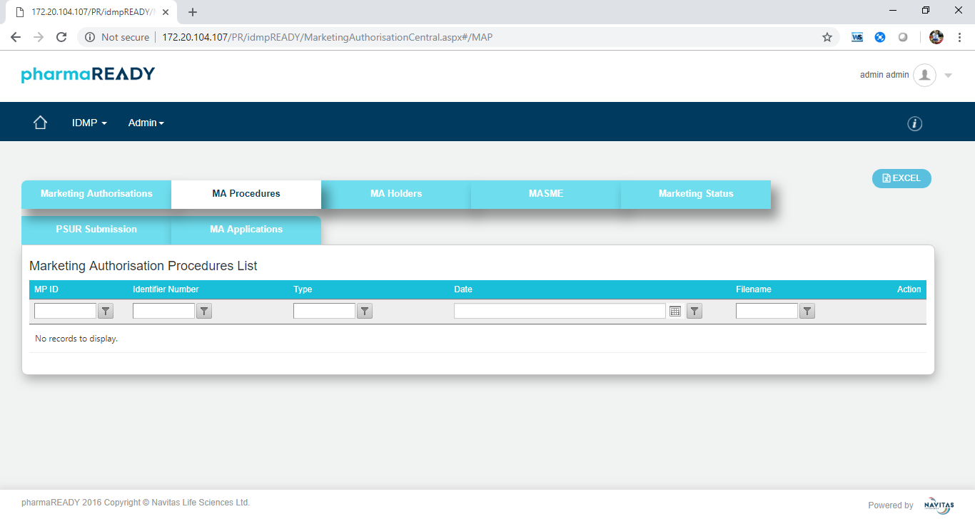

Figure 4.3.4.3.3 **Marketing Authorisation Procedure Grid View**

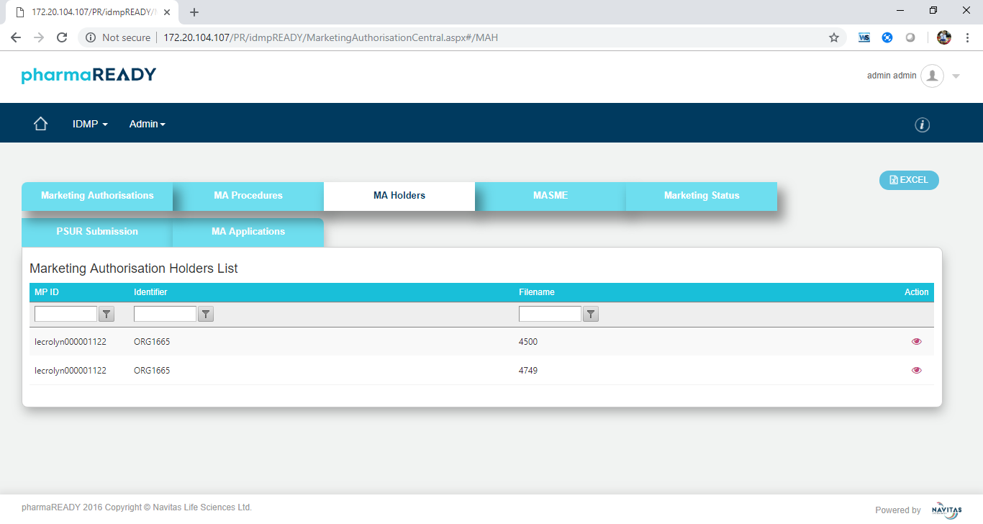

Figure 4.3.4.3.4 **Marketing Authorisation Holders Grid View**

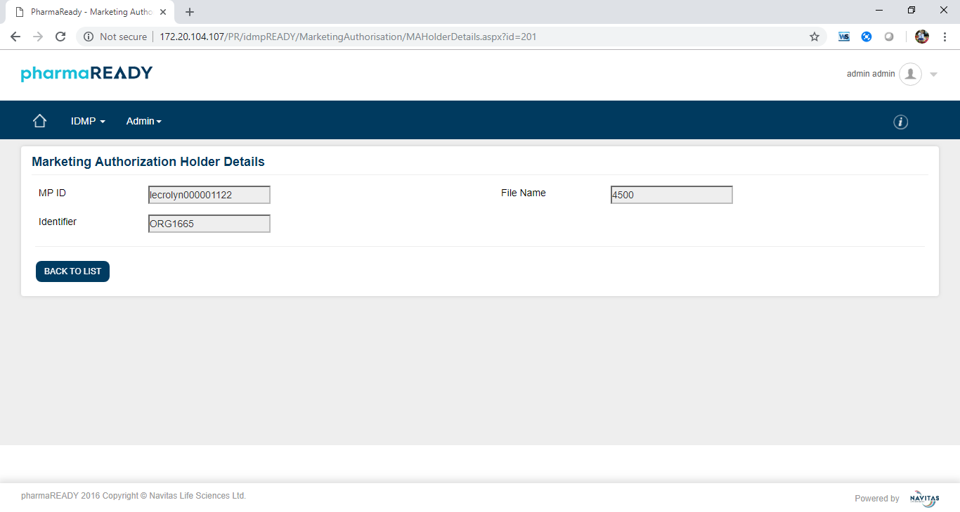

Figure 4.3.4.3.5 **Marketing Authorisation Holder Details View**

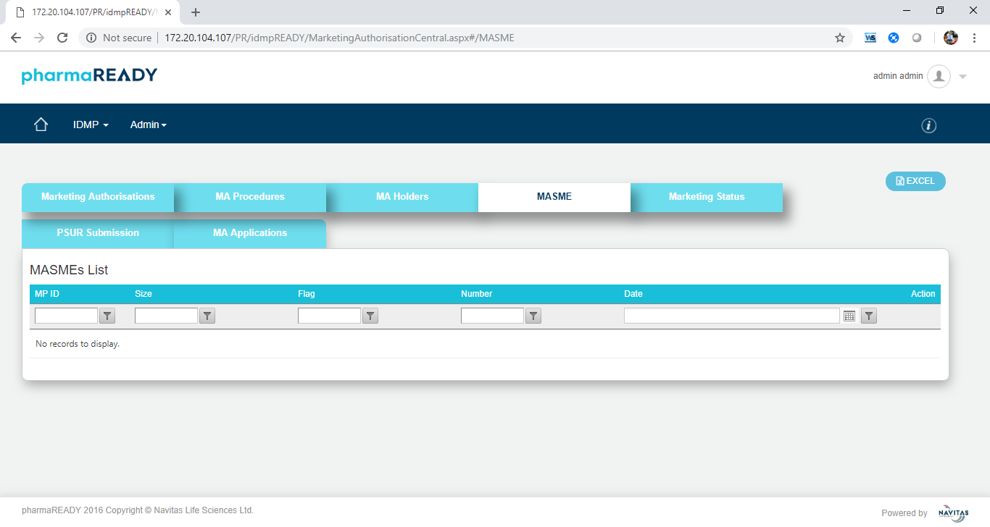

Figure 4.3.4.3.6 **Marketing Authorisation SME Grid View**

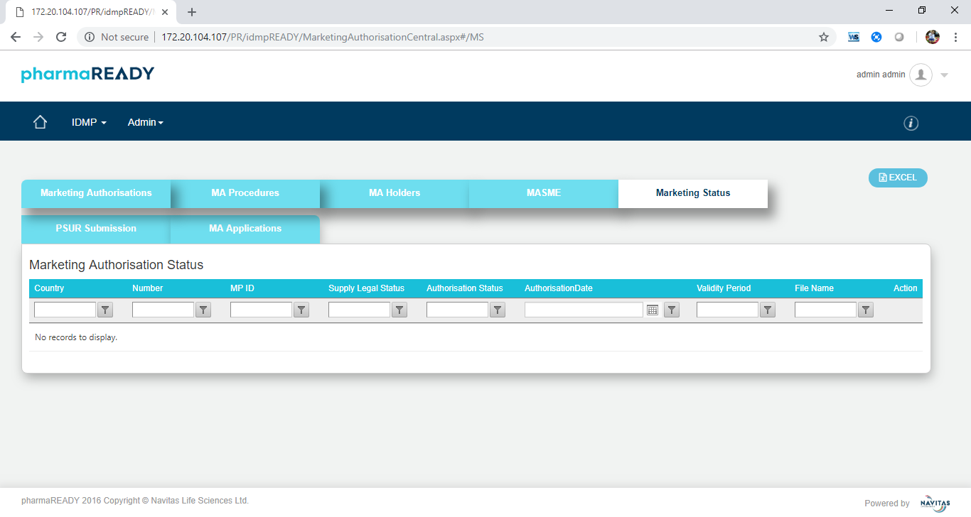

Figure 4.3.4.3.7 **Marketing Authorisation Status Grid View**

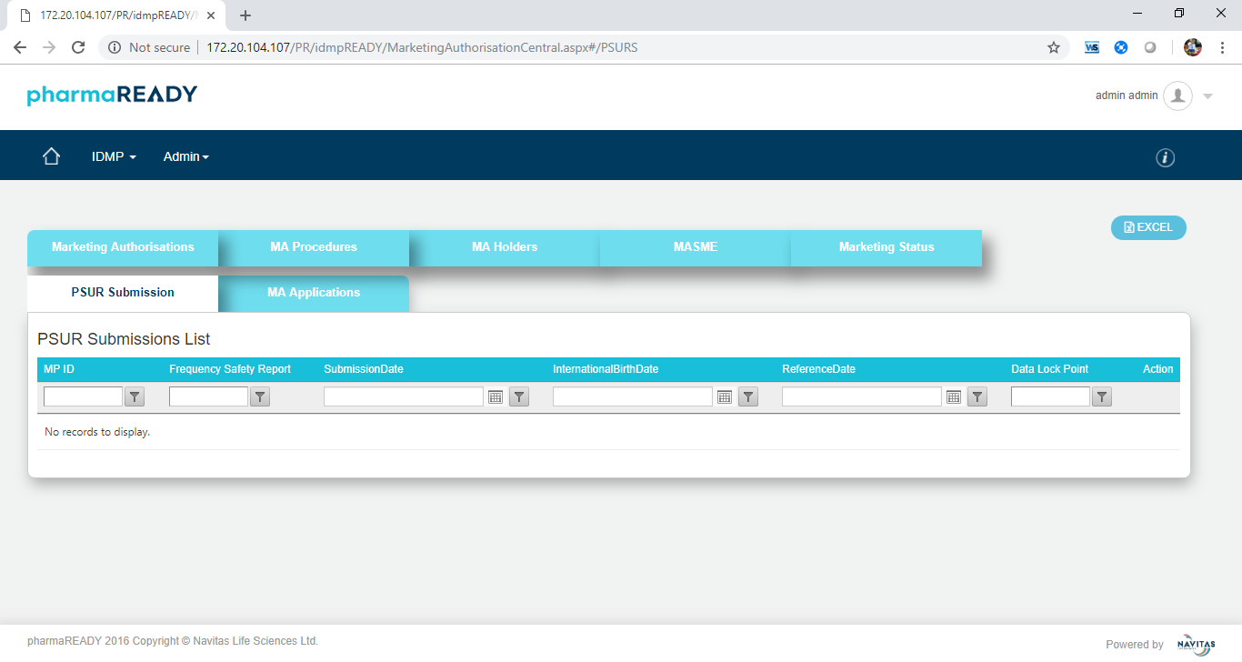

Figure 4.3.4.3.8 **PSUR Submission Grid View**

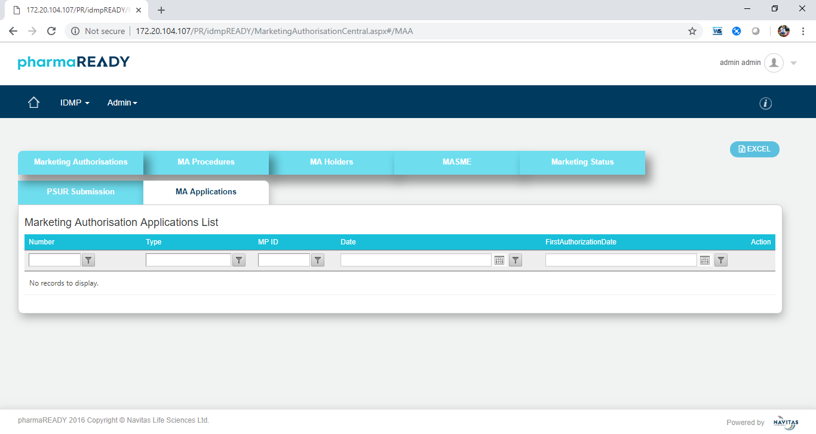

Figure 4.3.4.3.7 **Marketing Authorisation Applications Grid View**

* + - 1. **Packaged Medicinal Product**

All attributes are in the read-only mode in view screen. The screens are look like below

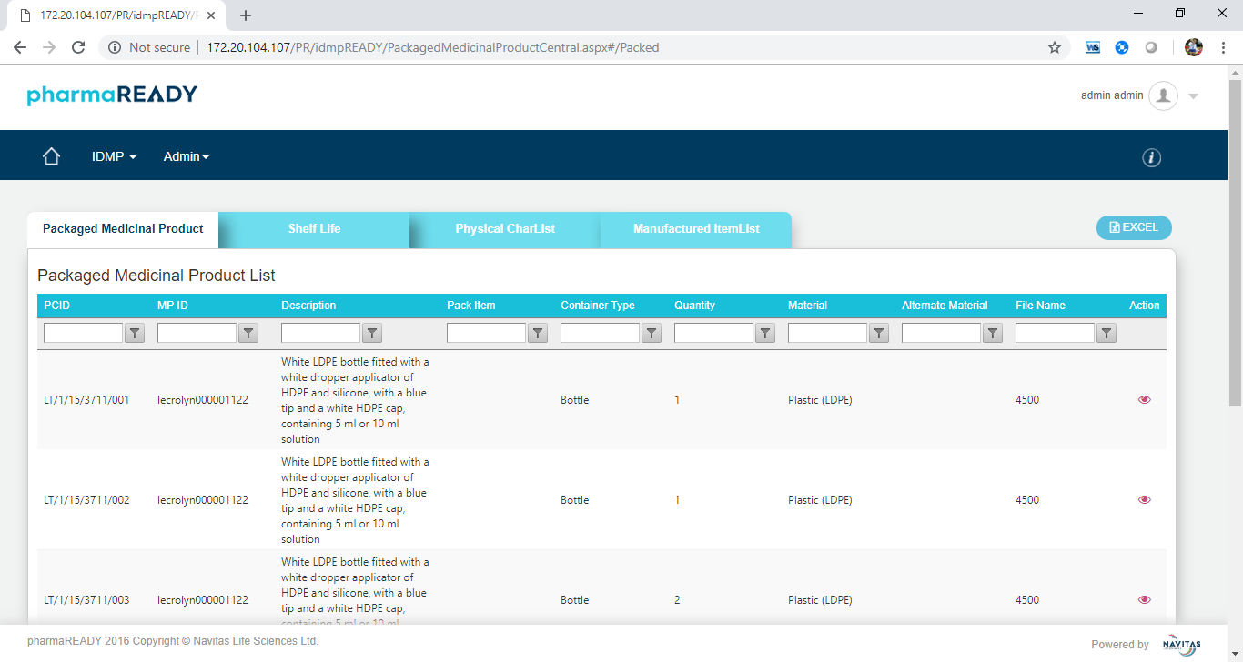

Figure 4.3.4.4.1 **Packaged Medicinal Product List Grid View**

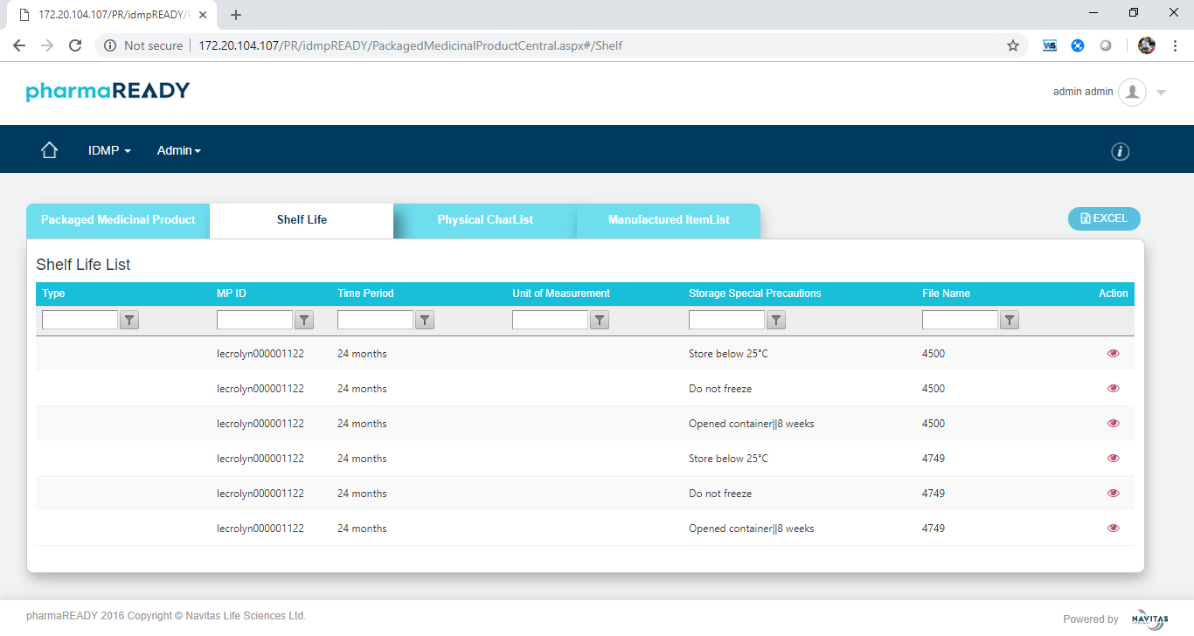

Figure 4.3.4.4.2 **Shelf Life Grid View**

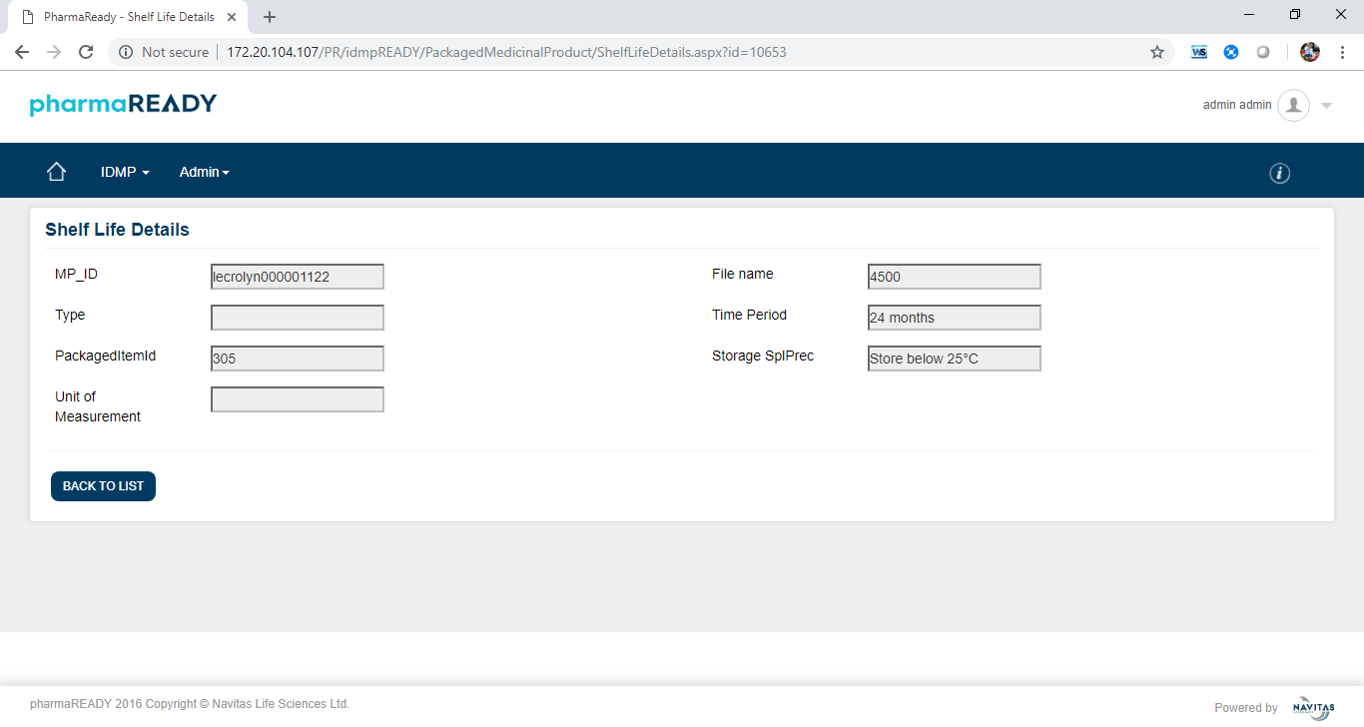

Figure 4.3.4.4.3 **Shelf Life Details View**

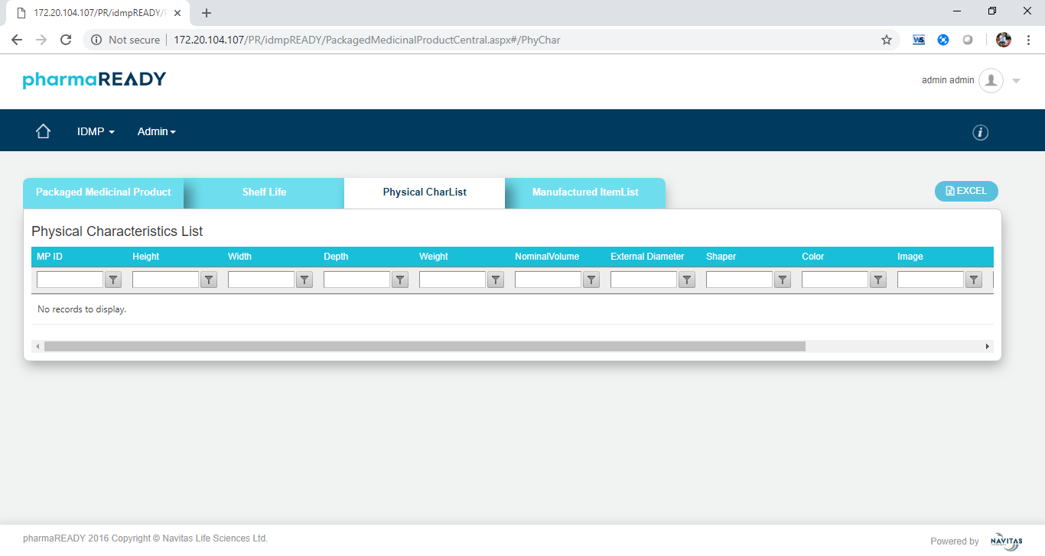

Figure 4.3.4.4.4 **Physical Characteristics Grid View**

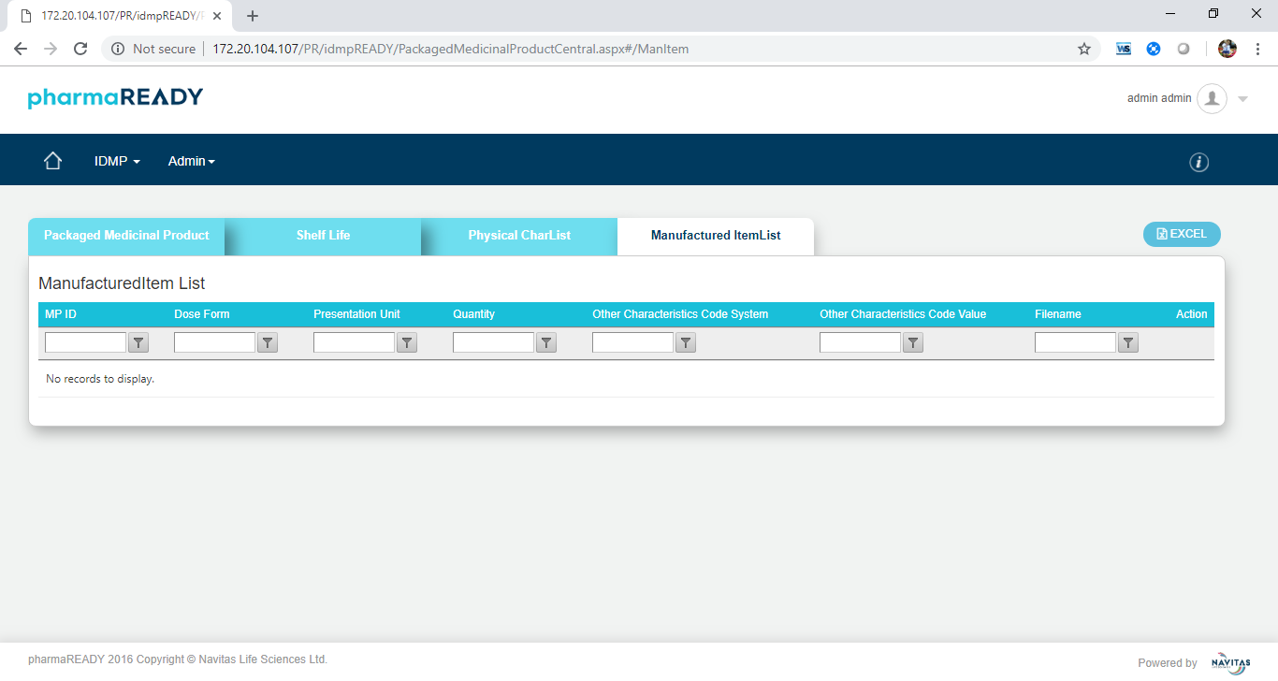

Figure 4.3.4.4.4 **Manufactured Item List Grid View**

* + - 1. **Pharmaceutical Product**

All attributes are in the read-only mode in view screen. The screens are look like below

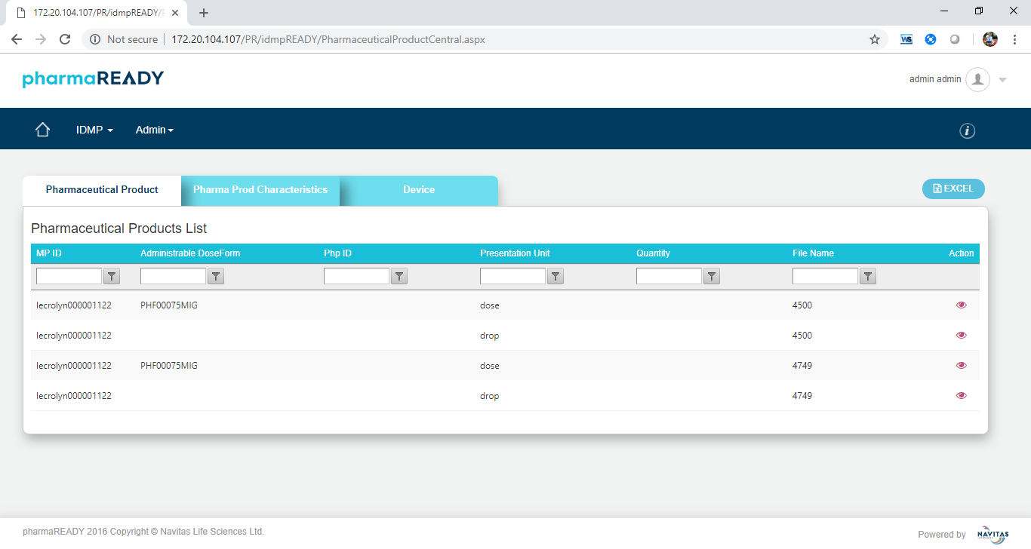

Figure 4.3.4.5.1 **Pharmaceutical Product List Grid View**

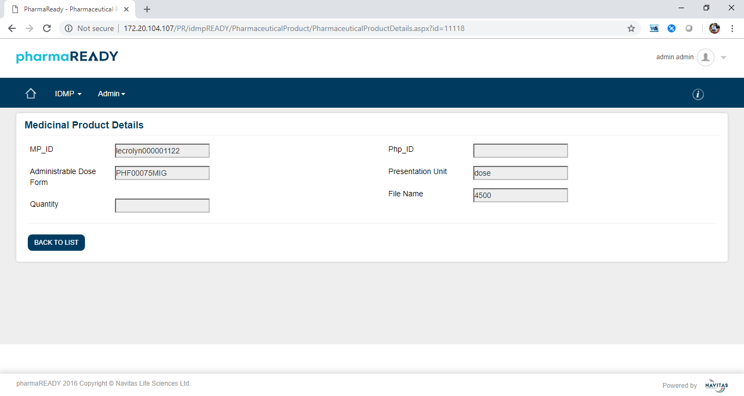

Figure 4.3.4.5.2 **Pharmaceutical Product Details Grid View**

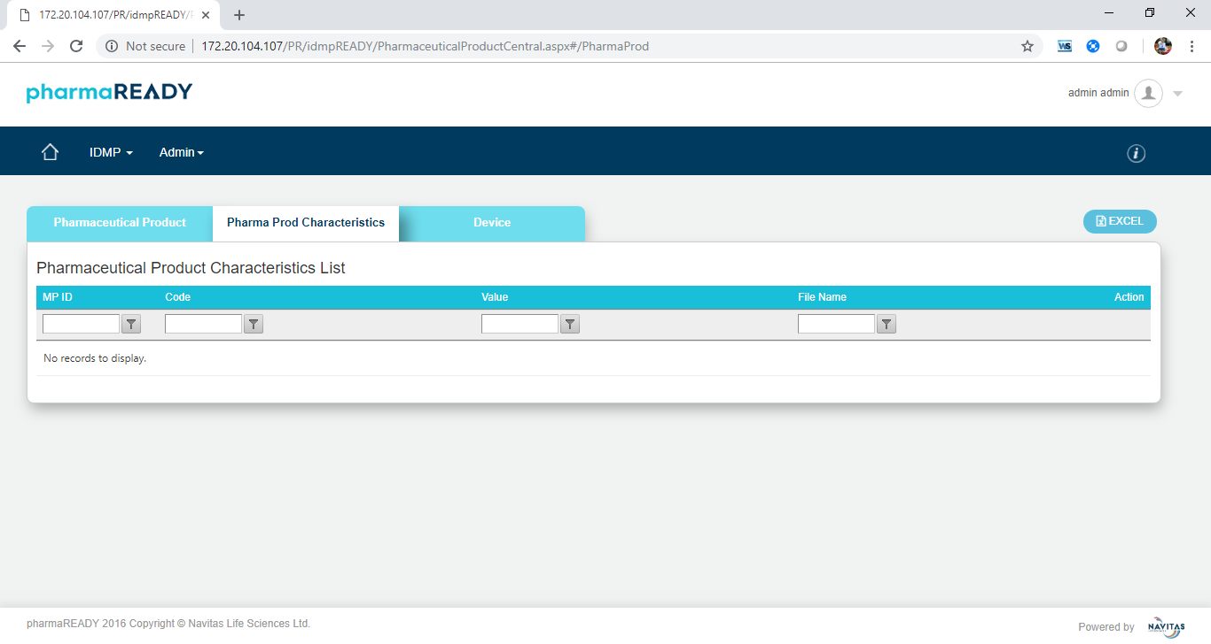

Figure 4.3.4.5.3 **Pharmaceutical Product Characteristics Grid View**

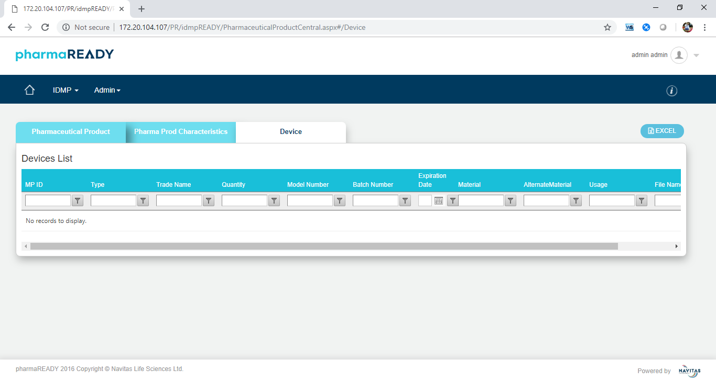

Figure 4.3.4.5.4 **Device Grid View**

* + - 1. **Substances**

All attributes are in the read-only mode in view screen. The screens are look like below

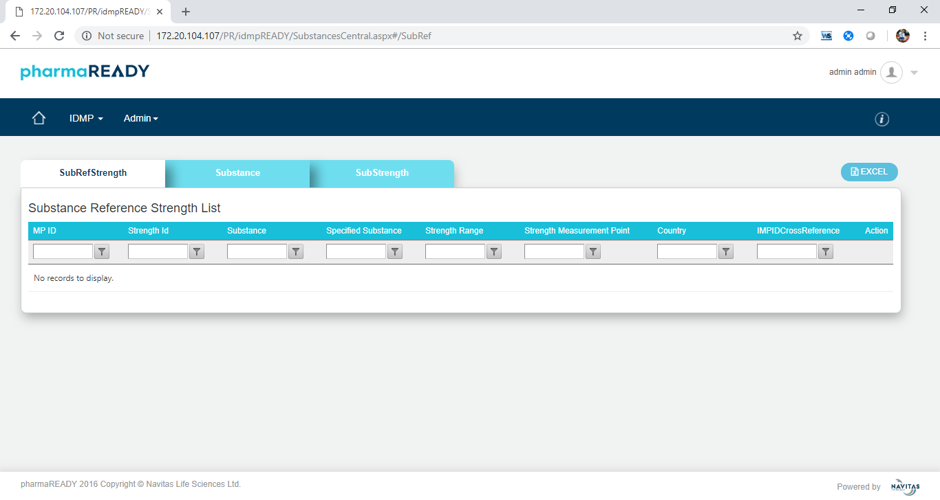

Figure 4.3.4.6.1 **Substance Reference Strength Grid View**

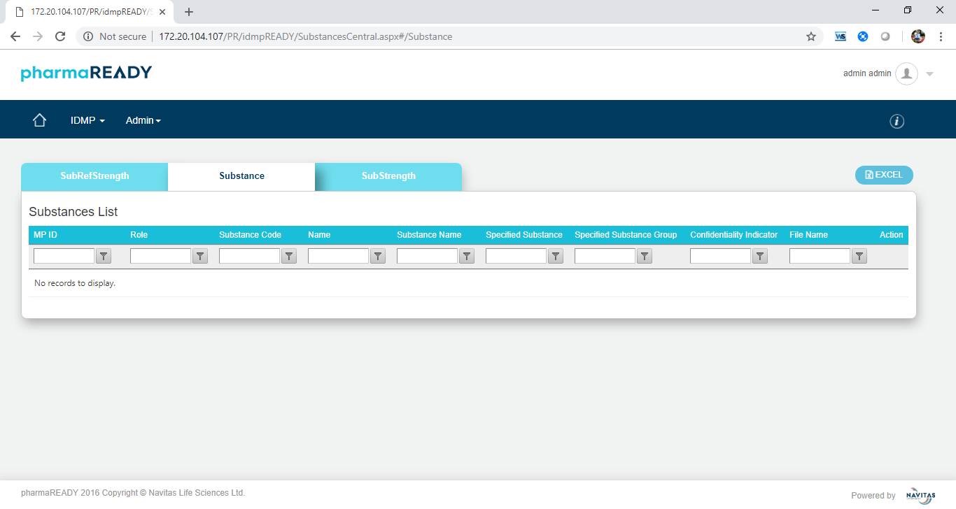

Figure 4.3.4.6.2 **Substance Grid View**

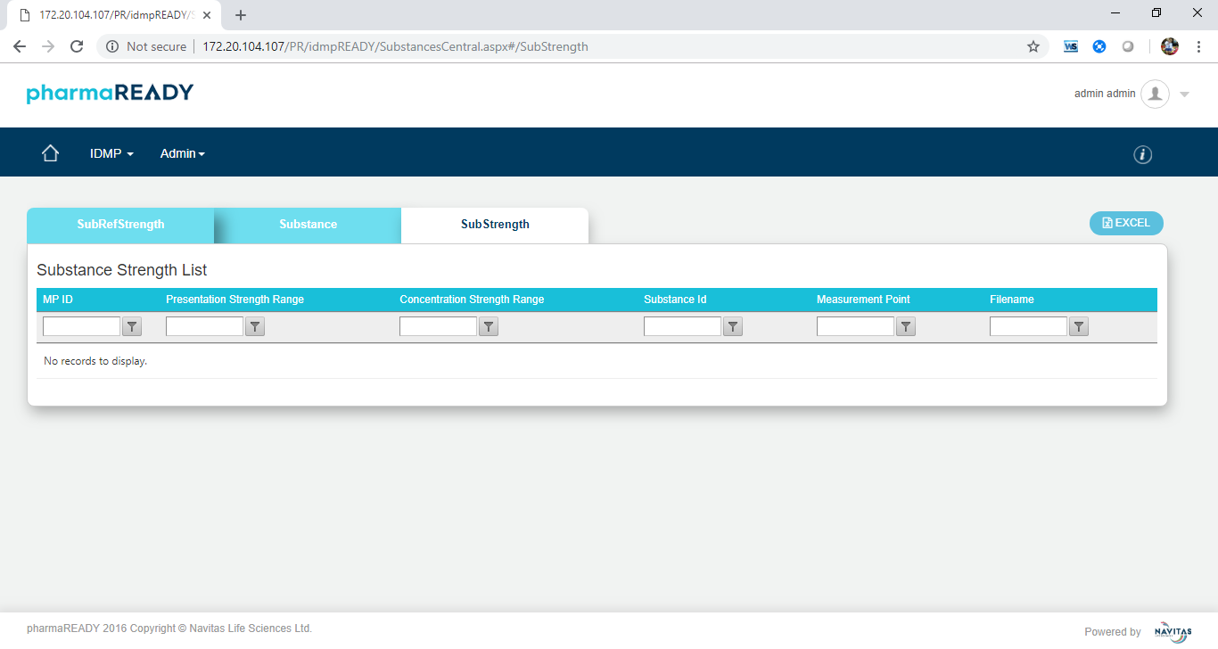

Figure 4.3.4.6.3 **Substance Strength Grid View**

* + - 1. **Manufacture**

All attributes are in the read-only mode in view screen. The screens are look like below

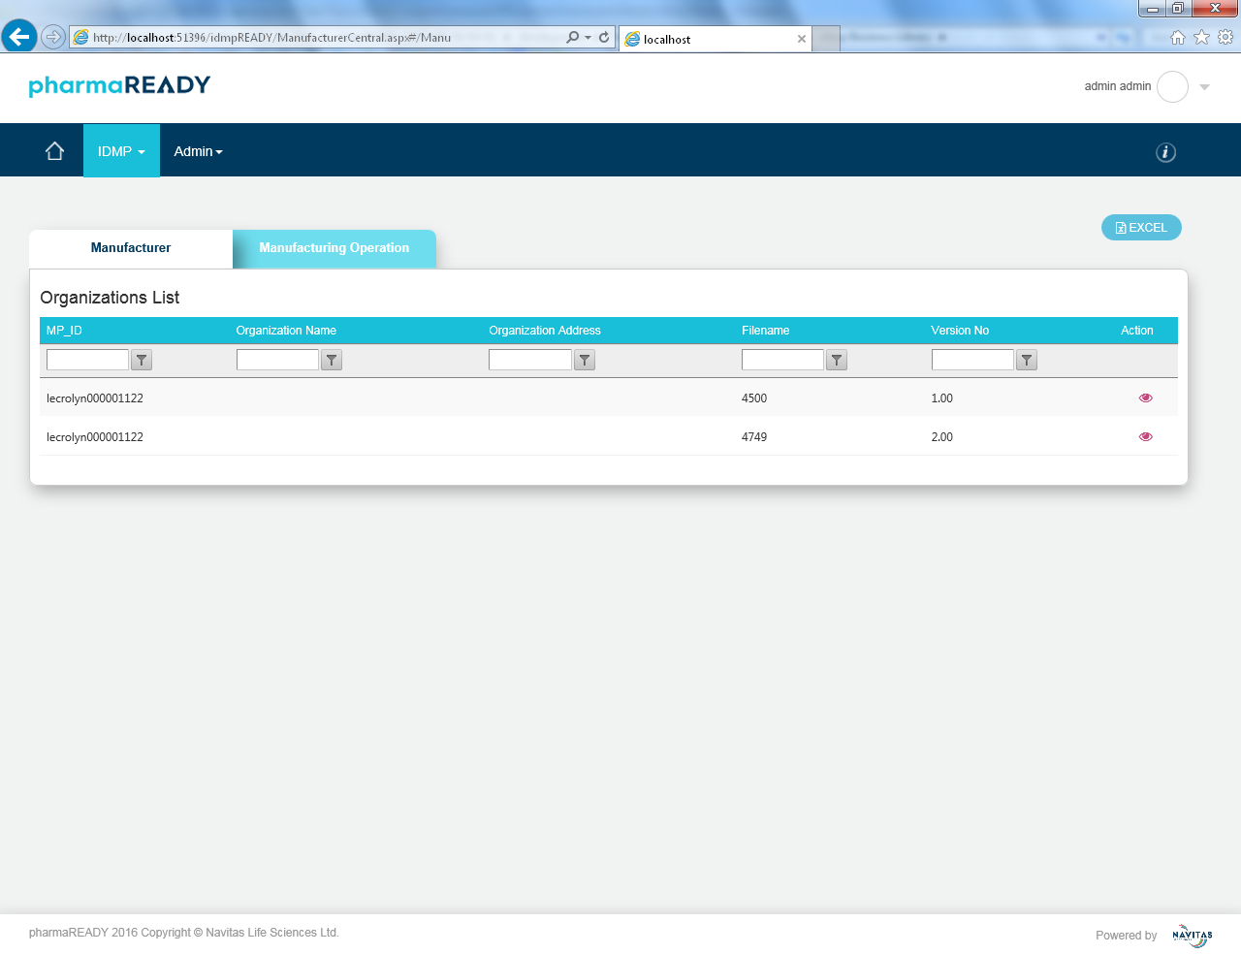

Figure 4.3.4.7.1 **Manufacture Grid View**

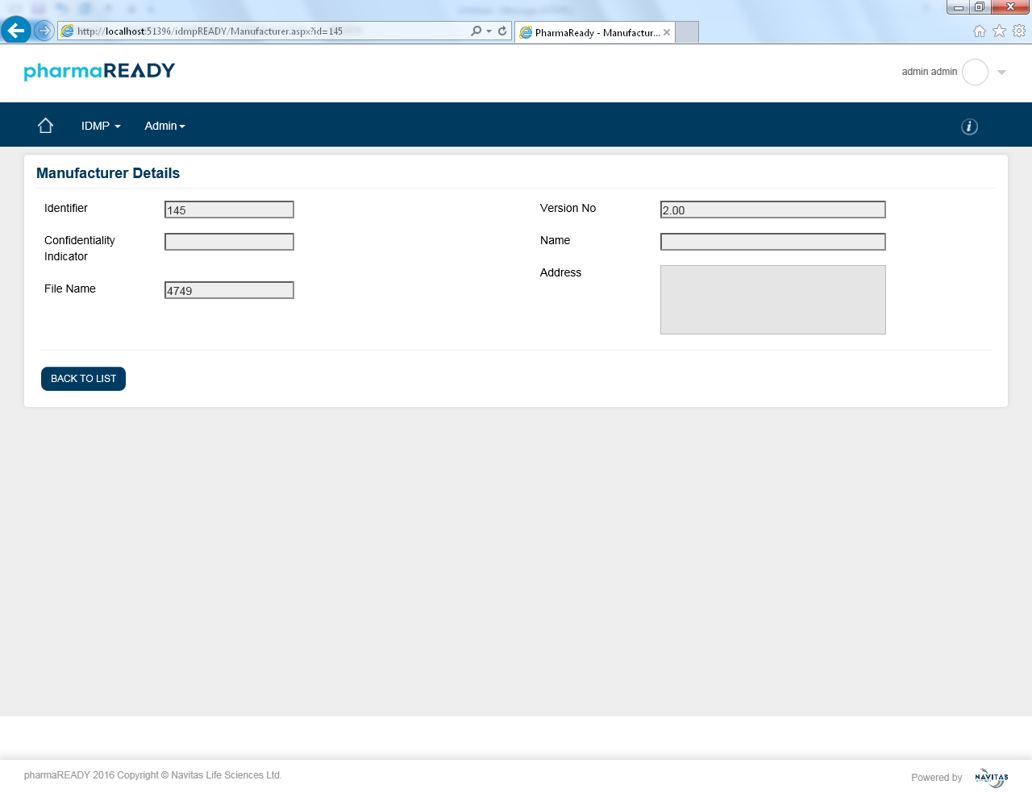

Figure 4.3.4.7.2 **Manufacture Details View**

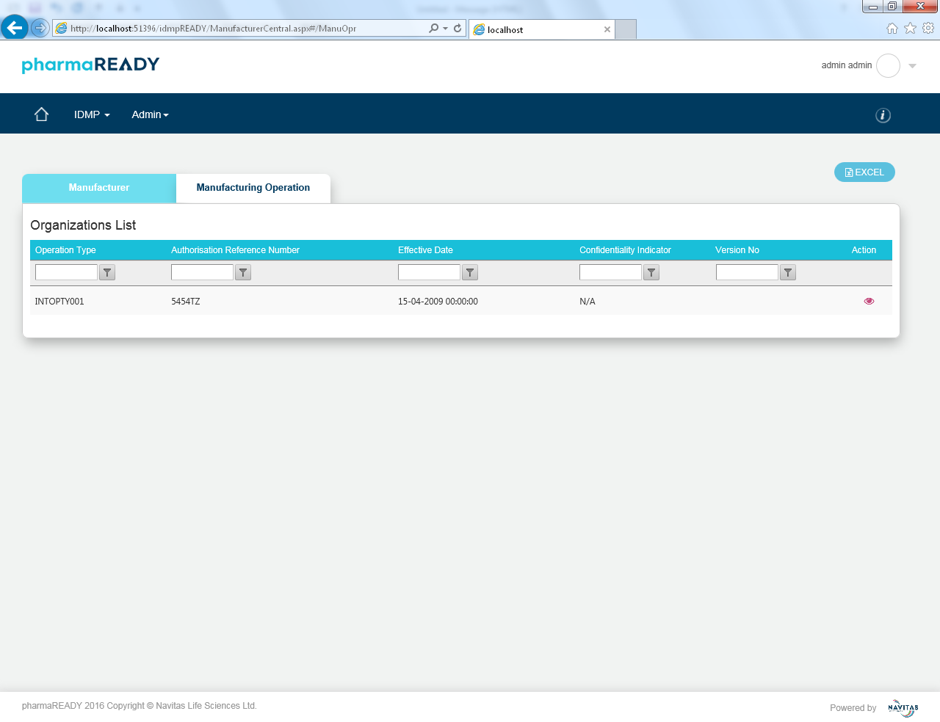

Figure 4.3.4.7.3 **Manufacturing Operation Grid View**

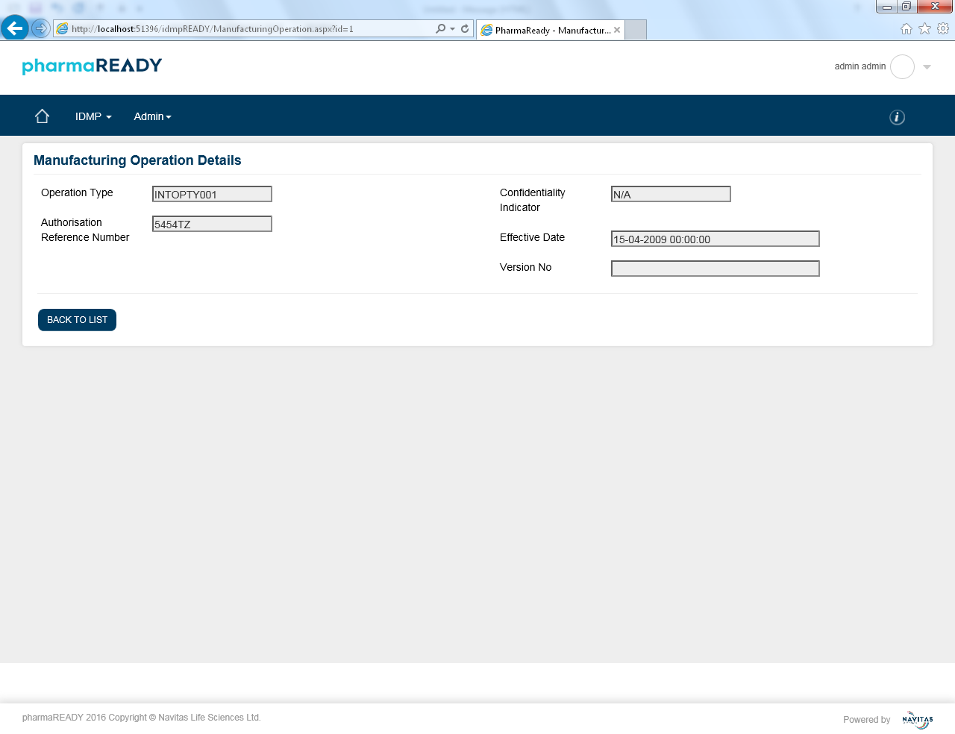

Figure 4.3.4.7.1 **Manufacturing Operation Detail View**

### Product Data

This is heart of the IDMP application. It is used to map all the attributes to respective EMA published IDMP model. The values are display and pushed to IDMP repository based on this configuration.

The *Product Data* page is similar to the following below.

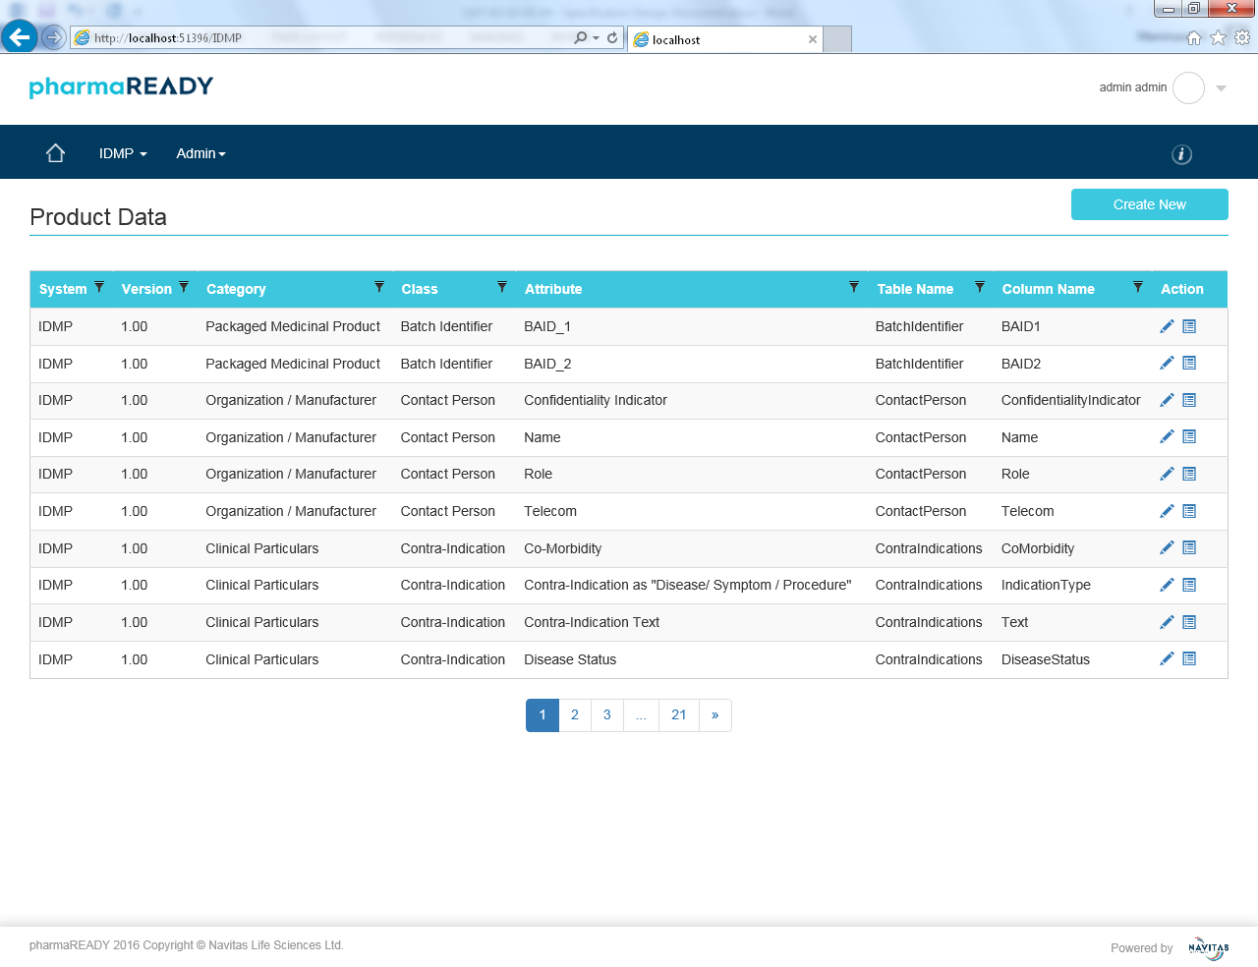

Figure 4.3.5.1 **Product Data List Grid View**

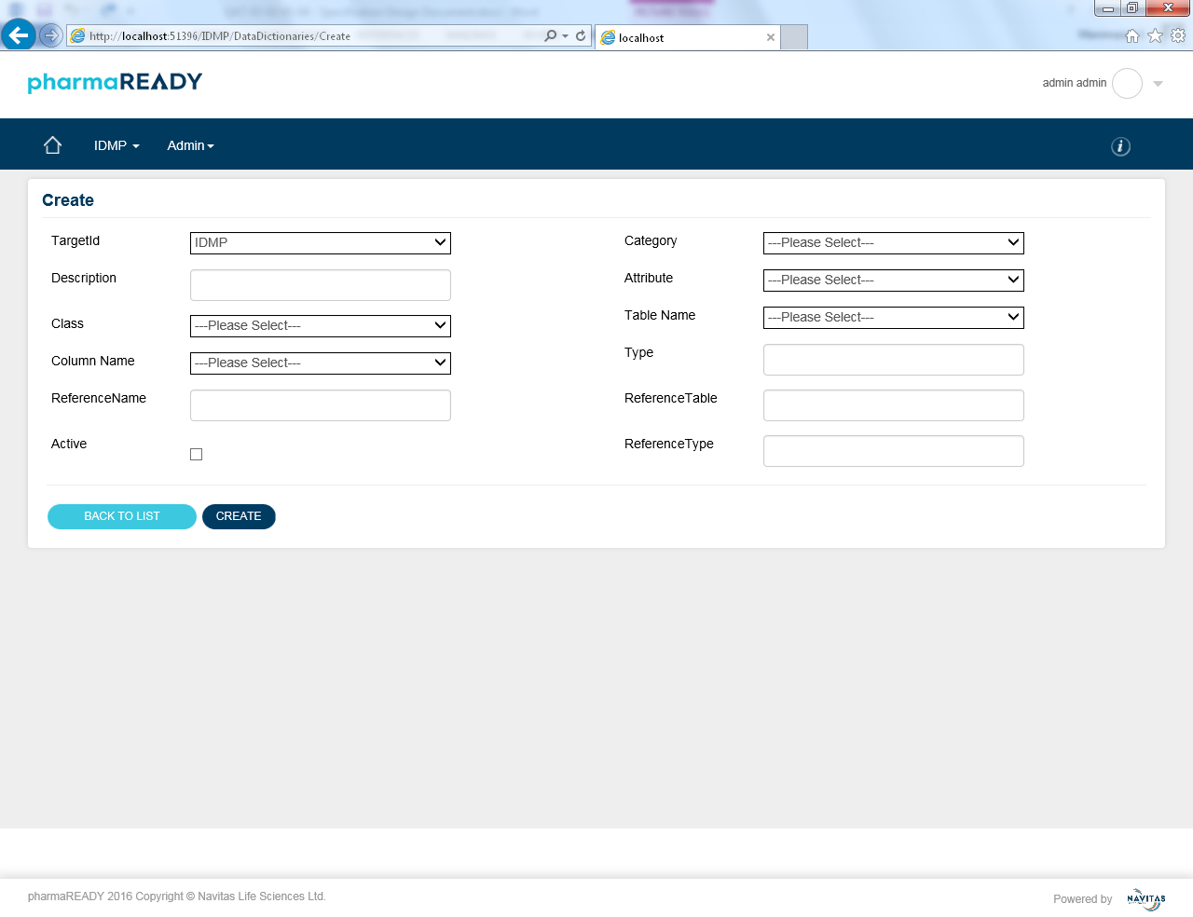

Figure 4.3.5.2 **Product Data Create View**

|  |  |  |  |  |  |  |  |  |  |  |  |
| --- | --- | --- | --- | --- | --- | --- | --- | --- | --- | --- | --- |
| PRD-01 | | |  | | The *Product Data Create* page displays the following fields below. | | | | | | |
|  | Label | | Type | | Options | Required Field? | Access Rules | Default Value | Max Length | Validation? | |  |
| A | TargetId | | Dropdown | | List of values from “DataTargets” schema | Yes |  | <First record from DataTargets> |  | No | | 1.0 |
| b | Description | | Textbox | |  | No |  |  | 500 | No | | 1.0 |
| c | Category | | Dropdown | | Fetch values from Meta table | Yes |  | <Please Select first> | 150 | No | | 1.0 |
| d | Attribute | | Dropdown | | Fetch values from Meta table | Yes |  | <Please Select first> | 150 | No | | 1.0 |
| e | Class | | Dropdown | | Fetch values from Meta table | Yes |  | <Please Select first> | 150 | No | | 1.0 |
| f | Table Name | | Dropdown | | List of table name from configured IDMP database | Yes |  | <Please Select first> | 50 | No | | 1.0 |
| g | Column Name | | Dropdown | | List of column name from configured IDMP database based on the selected table | Yes |  | <Please Select first> | 50 | Table name should be selected | | 1.0 |
| h | Type | | Textbox | | Column Data type | Yes |  |  | 50 |  | |  |
| i | Reference Name | | Textbox | | Column Data type | Yes |  |  | 50 |  | |  |
| j | Reference Table | | Textbox | | Column Data type | Yes |  |  | 50 |  | |  |
| k | Reference Table | | Textbox | | Column Data type | Yes |  |  | 50 |  | |  |
| l |  | | Button | |  | No |  |  |  | Database has to be selected | | 1.0 |

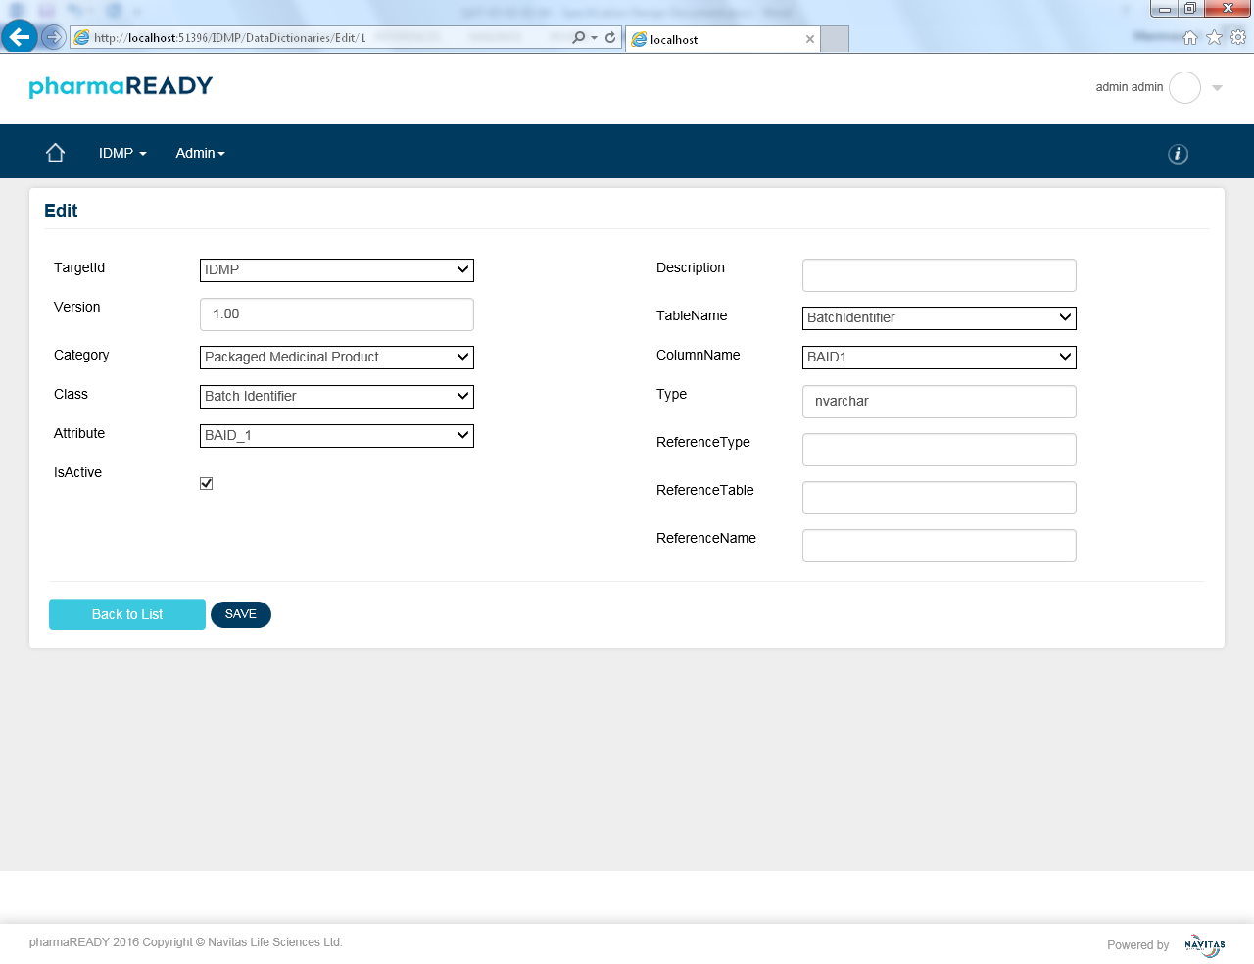

Figure 4.3.5.3 **Product Data Edit View**

|  |  |  |  |  |  |  |  |  |  |  |  |
| --- | --- | --- | --- | --- | --- | --- | --- | --- | --- | --- | --- |
| PRD-01 | | |  | | The *Product Data Edit* page displays the following fields below. | | | | | | |
|  | Label | | Type | | Options | Required Field? | Access Rules | Default Value | Max Length | Validation? | |  |
| A | TargetId | | Dropdown | | List of values from “DataTargets” schema | Yes |  | <First record from DataTargets> |  | No | | 1.0 |
| b | Description | | Textbox | |  | No |  |  | 500 | No | | 1.0 |
| c | Category | | Dropdown | | Fetch values from Meta table | Yes |  | <Please Select first> | 150 | No | | 1.0 |
| d | Attribute | | Dropdown | | Fetch values from Meta table | Yes |  | <Please Select first> | 150 | No | | 1.0 |
| e | Class | | Dropdown | | Fetch values from Meta table | Yes |  | <Please Select first> | 150 | No | | 1.0 |
| f | Table Name | | Dropdown | | List of table name from configured IDMP database | Yes |  | <Please Select first> | 50 | No | | 1.0 |
| g | Column Name | | Dropdown | | List of column name from configured IDMP database based on the selected table | Yes |  | <Please Select first> | 50 | Table name should be selected | | 1.0 |
| h | Type | | Textbox | | Column Data type | Yes |  |  | 50 |  | |  |
| i | Reference Name | | Textbox | | Column Data type | Yes |  |  | 50 |  | |  |
| j | Reference Table | | Textbox | | Column Data type | Yes |  |  | 50 |  | |  |
| k | Reference Table | | Textbox | | Column Data type | Yes |  |  | 50 |  | |  |
| l |  | | Button | |  | No |  |  |  | Yes | | 1.0 |

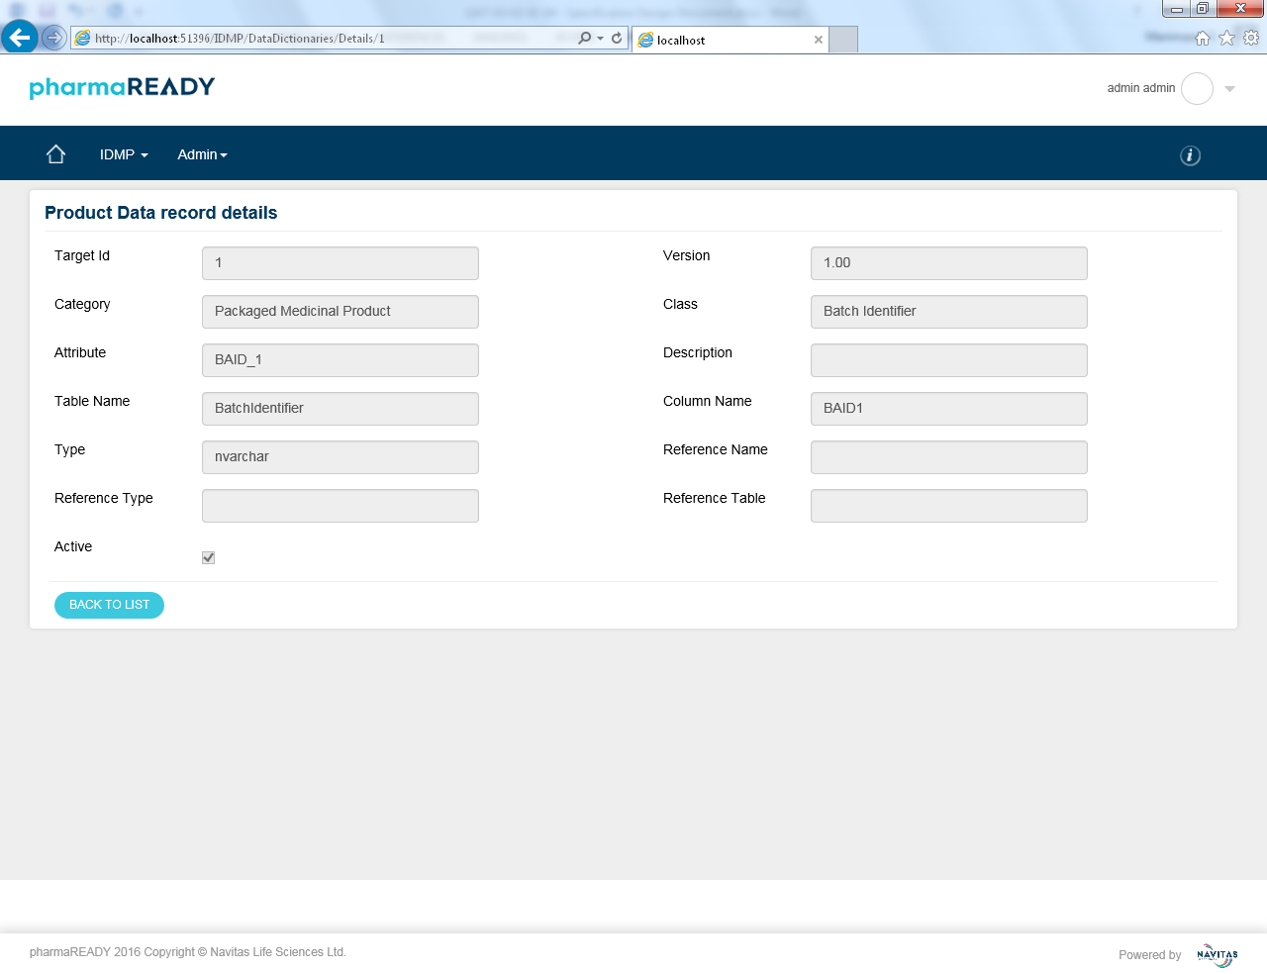

Figure 4.3.5.4 **Product Data record detail View**

The *Product Data record detail view* page displays the details as non-editable fields.

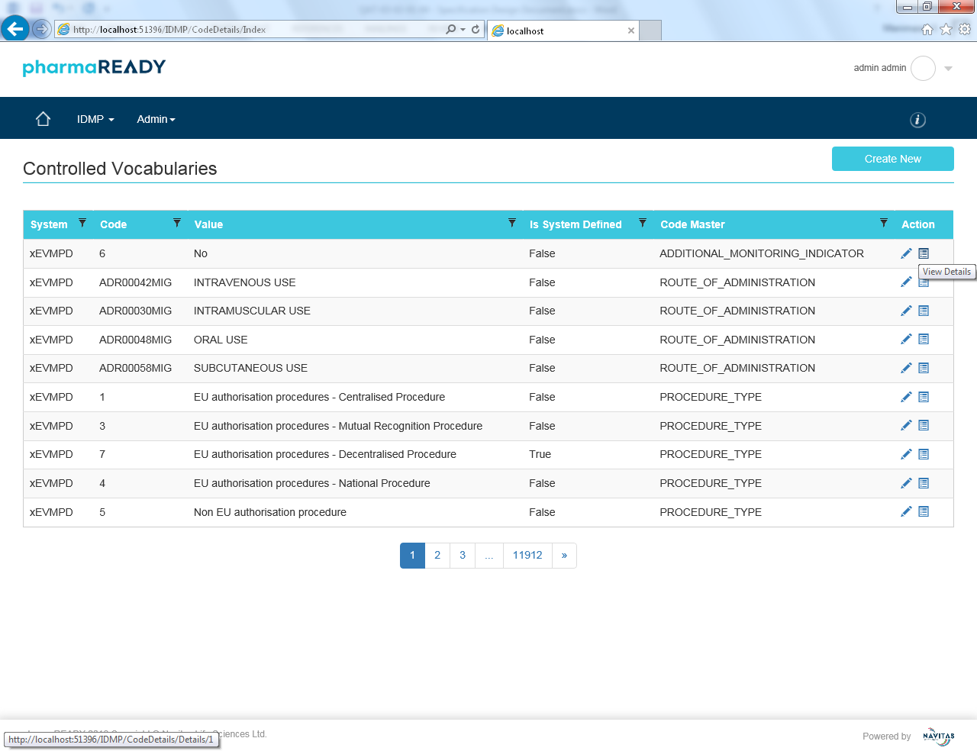

## Hardware/Software Specifications

PharmaREADY is implemented on multiple hardware platforms. This section defines the hardware and software specifications and configuration details associated with those devices.

### Server Platform

A Web/Application/Database Server provides pharmaREADY functionality.

|  |  |  |  |
| --- | --- | --- | --- |
| SVR-01 |  | The pharmaREADY Server has the following hardware specifications below.   1. Processor: Dual Intel Xeon processors, 2 GHz or higher 2. Memory: 8 Gigabytes (GB) of RAM 3. Hard Disk: 500 GB of available RAID controlled hard disk space plus 225% of projected document/file storage needs 4. Drives: CD-ROM drive 5. Display: VGA, Super VGA 6. Mouse: Microsoft Mouse 7. Other Devices: Fast Ethernet NIC | 1.0 |
| SVR-02 |  | The pharmaREADY Server includes the following software components below.   1. Windows 2003 Server or above 2. Microsoft .NET Framework 4.0 3. Microsoft SQL Server 2008 or above 4. SharePoint foundation 2010 5. SharePoint Portal Server 2003 (optional) 6. Microsoft SQL Server 2016 SQL Reporting Services 7. If the PDF Conversion is used, Microsoft Office 2010 | 1.0 |
| SVR-03 |  | The pharmaREADY Server is accessible via the public Internet. | 1.0 |
| SVR-04 |  | The pharmaREADY Server is able to send email to users external to the server. | 1.0 |

### Client Workstation Specifications

pharmaREADY users access program functions using a web browser on their client workstation.

|  |  |  |  |
| --- | --- | --- | --- |
| CWS-01 |  | Supported pharmaREADY workstations require the following below.   1. Microsoft Windows NT, 2000, 7, 8 and XP operating systems configured to use the United States English language 2. An Internet Explorer 11.0 web browser with Microsoft Visual Basic Scripting support and installed Active-X control for report printing 3. Networked or dial-up access to the Internet on a 28.8k modem or faster 4. An established account with an Internet Service Provider (ISP) or corporate Internet account | 1.0 |

### 4. 3 Third Party Controls Used

ASPOSE Component is used for document conversion from word, excel, PowerPoint and PDF to regulatory compliance PDF document

Telerik UI control for ASP.NET

# Appendix

## Glossary

|  |  |
| --- | --- |
| Term | Description |
| Access Rights | A specific functional permission that is associated with a role |
| Author | A user who is authorized to upload the different sources and perform the process activity |
| Review | Reviewer can review the source values also any attribute value is wrong then reviewer can able to modify the value. |
| Approve | Approver view the final values and publish the values in to IDMP repository. |
| View | Viewer will able to view all the IDMP attribute values in read-only mode |
| Admin | Admin will perform all configuration works related to IDMP application |
|  |  |
|  |  |
|  |  |
|  |  |
|  |  |
|  |  |
|  |  |

# References

<Specify the SRS/related documents>

# Change History

|  |  |  |  |
| --- | --- | --- | --- |
| Date | Ver.# | Change Description | Reason For Changes |
| 03-Jan-2019 | 1.0 | Initial version |  |
|  |  |  |  |
|  |  |  |  |
|  |  |  |  |
|  |  |  |  |

# 